**Technical Report for**

**Design and Development**

**of Data Storage Solutions for Analysis**

**By: -**

**Rahul Ramchandra Uppari (10523807)**

# Contents

Contents 1

1. INTRODUCTION 3

1.2. Reasons for selecting the subject area AND DATA 3

1.3. Vision and Goals 3

1.4. Key StakeHolders 4

1.5. Business requirements 5

2. SCHEMA 6

3. ETL USING SSIS 7

4. VISUALIZATIONS AND REPORTS 11

4.1. Visualizations 12

4.2. Reports 16

5. XML and Schema 21

6. Graph Databases 24

6.1. COMPARISON To Relational Databases 29

7. Bibliography 34

Appendix A – Visualization Code 36

Appendix B – Neo4J Code 36

Appendix C – XML Code 37

Appendix D – Datawarehouse Create Queries 37

# 1. INTRODUCTION

Data Storage solutions are huge repositories, where data is stored electronically and makes its accessibility and retrievability easy and reliable. They can be In-House, or Cloud based storage solutions. Data warehousing is a technique of constructing and utilizing a Data Warehouse, that is generally in-house, i.e. on an actual physical server, which is the huge repository where data is collected and stored from transactional systems, relational systems, and other resources.

To demonstrate a data storage solution, we chose **Crash Reporting - Drivers Data** Dataset which was recorded by Automated Crash Reporting System (ACRS) of the Maryland State Police, and reported by the Montgomery County Police, Gaithersburg Police, Rockville Police, or the Maryland-National Capital Park Police Data.world. (2019). This dataset provides information on motor vehicle operators (drivers) involved in traffic collisions occurring on county and local roadways. The dataset reports details of all traffic collisions occurring on county and local roadways within Montgomery County. Source of the data can be found on:

<https://data.world/montgomery-county-of-maryland/0ca5b758-c60a-40c7-bfb5-fda26ceee4c8>

## 1.2. Reasons for selecting the subject area AND DATA

Our main reason for selecting the subject area was to gain insight into real-life data instead of going for a fictional data. Datasets such as market-basket, customer-product etc., although good for understanding data storage solutions and allied concepts, don’t give us information whose analysis can actually benefit the common man. Car crashes / accidents is one of the major causes of human casualties across the world. And when it comes to the possible reasons behind such unfortunate events, it can range from human errors to environmental factors. We wanted to explore this subject area and find potential patterns / interesting facts which can give us more information about the reasons causing these accidents. Our main focus during this entire project was to find subjects of analysis which, if addressed properly, can actually reduce car crashes. Moreover, dealing with raw data collected by on-sight authorities and crash reporting systems has given us much more insight into dealing with real-life data and associated tasks and challenges.

## 1.3. Vision and Goals

When it comes to our dataset, the main subject of analysis is the number of crashes which equates the number of lives at risk, so there is a lot of scope for improvement as each and every life matters.

Our ultimate vision from this study is to mitigate the number of car crashes especially those which are avoidable if drivers act more responsibly. Further, we wish to supply our reports and findings to authorities which can benefit from this information and can work towards providing safer roads to the entire public.

GOALS:

* To bring down the number of car crashes.
* To act as a central source of data for companies working on integrating AI and machine learning in cars.
* To act as a data source for traffic controlling authorities where more interceptors/presence is required.
* To act as a guide for awareness within the community focusing on safe driving.
* To act as a guide source for municipal authorities to work on areas that need attention with respect to traffic safety.

## 1.4. Key StakeHolders

* Driver

Drivers can use this data or rather generated reports to gain better insight on accident prone areas, road safety and safe driving in general.

* Driving Schools

They can use this data for educating upcoming drivers about road safety and traffic rules when it comes to drunk driving etc.

* Indirect victim/any other person involved in the car crash

Usually car crashes have a ripple effect where a lot of surrounding people/physical objects are affected by the same. A person sitting in the passenger seat; passengers in other surrounding vehicles; sometimes car crashes damage surrounding property for example, A roadside café where the owner/people in the café are indirect victims; A lot of times heavy transport vehicles carrying tons of goods, oil, equipment etc. are involved in car crashes which result in huge losses. This data can help these indirect victims to be better prepared for unexpected events like these, for example, heavy transportation vehicles can carry out operations during the time of non-rush hour.

* Authorities

Traffic police can use this data to establish more presence in accident prone areas in order to regulate traffic. Health and Fire departments can set up outposts near accident prone areas for quick and immediate reaction in case of an accident. Municipal authorities can use this data for road repairs, improving street lighting etc. as a precaution.

## 1.5. Business requirements

* Better Data Collection:

While dealing with this dataset, we realized that there are a lot of NULL, N/A and Unknown values present. This is a clear indication that the data collection process is not optimal by ACRS (Automated Crash Reporting System). This means there are a lot of factors unknown when it comes to the accidents which occurred. Finding these details would result into a better understanding of the data set, which leads to better prediction and analysis and in-turn means that more lives can be saved, and more casualties are avoided.

* Better Prediction

Weather and climatic conditions always have a significant influence on car crash incidents. Slippery roads during rain, smog/fog during winters causing low visibility, hailstorm during winters etc. all contribute to unfavorable conditions which can lead to these accidents. Improving the existing weather forecasting technology would mean better alert system to notify drivers. This would mean people could avoid severe weather conditions that might cause car accidents.

* Involving Car Companies

The integration of AI and Machine Learning in the automobile industry has been one of the greatest innovations in the world of technology. Automobile giants Tesla Motors have successfully incorporated auto pilot and self-driving in their cars. They have already prevented many car crashes using their auto pilot which could have happened due to the driver falling asleep behind the wheel. In order to optimize self-driving AI, data collected from car crashes can be of great benefit to companies like tesla. Drivers could get alerts of potential weather change in their daily commute routes. Cars could have inbuilt breathalyzers which would prompt the driver to do an alcohol leave check before the car switches on.

* Involving traffic control and other government authorities

Having more presence of traffic control authorities and interceptors spread across the entire state would help in controlling the traffic and in-turn prevent accidents. Areas with bad road quality and/or insufficient lightning can be addressed by the concerned authorities.

* Awareness within the community

People should be made aware of the consequences of drunk driving. Law enforcement authorities can increase penalties if caught driving under influence. Driving schools should have classes focusing on road safety, speed limit and all associated factors to keep in mind while driving.

# 2. SCHEMA

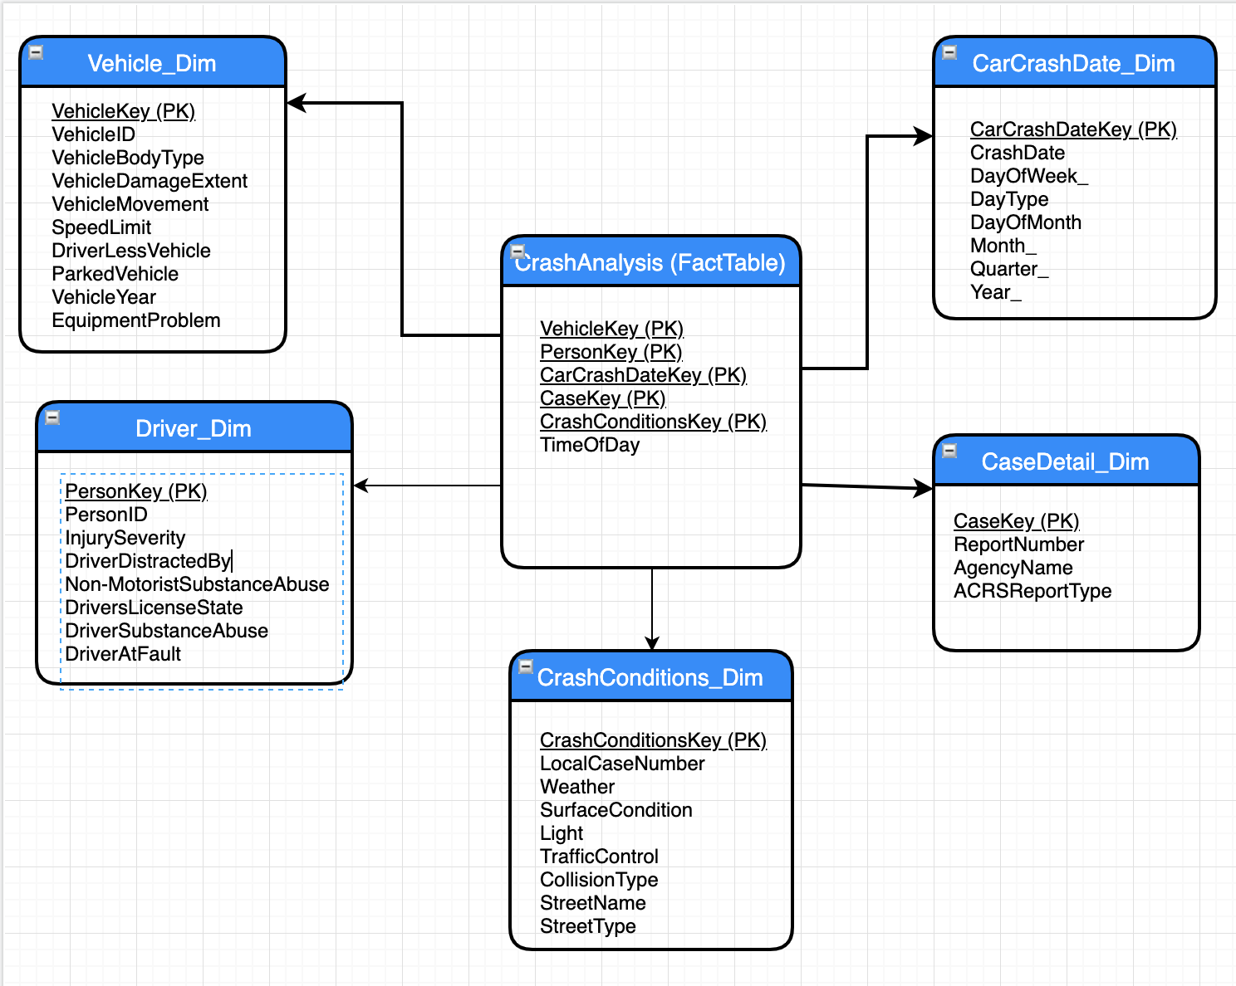

We have used a star schema for our data warehouse due to the following reasons:

* Queries run faster on a star schema as they have smaller number of tables and clear join paths.
* Dimensions are linked through a central fact table meaning that only a single path exists between multiple fact tables. This facilitates accurate and consistent query results.
* By separating data into 5 dimension tables and 1 fact table, the impact of load operation is greatly reduced.
* Since each record has a unique primary key in each table of a star schema, referential integrity is maintained from the beginning.
* Since all 5 dimensions are linked to 1 fact table, the star schema is easy to understand and navigate.

# 3. ETL USING SSIS

**SQL Server Integration Services** (**SSIS**) is a component of the Microsoft SQL Server database software that can be used to perform a broad range of data integration and data transformation tasks. It is basically an **ETL** tool part of the Microsoft Business Intelligence suit that is mainly used to achieve Data Integration.

Microsoft SQL Server Integration Services (**SSIS**) is a platform for building high-performance data integration solutions, including extraction, transformation, and load (**ETL**) packages for data warehousing.

SSIS is easier to maintain and package configuration. And it very useful when the database crashes we can recover the data using the same package which was used to import data in SQL SERVER database.

We faced few challenges while importing data through SSIS into the SQL Server database:

1. Data source cleaning is a must before importing data into the database, and for our project we have used an Excel data source in which we have formatted and removed the corrupted data before importing.
2. Understanding and applying the proper data type for a particular attribute was one of the major challenges, and for identifying the correct data type we have first examined the entire dataset in its entirety in excel itself and understood what would be corresponding the data type for the selected attribute while importing through SSIS into Dimension Tables & Fact Table in MS SQL Server Database.
3. Truncation of Data: Data truncation was one of the issues which happened because of incorrect datatype length for e.g. we used varchar (20) for particular attribute instead of varchar (50) which resulted in truncated data values. To debug this problem, we referred Stack Overflow and MSDN.
4. Inserting data into to the fact table was one of the hurdles we faced, and this happened because the data in the excel source and the dimension table lookup values were not matching, which resulted in data type error. To overcome this hurdle, we identified and matched the data for both the excel source and lookup values in input & output parameters tab.
5. To ensure the sequence of data type is not disturbed, we had used the SORT option in SSIS after the lookup values and then inserted the records into the Fact Table

Below are the Snapshot for the Dimension Tables and Fact Table populated with data from Excel using SSIS tool in Visual Studio.

**ETL Data Flow to load data in the DRIVER DIMENSION**

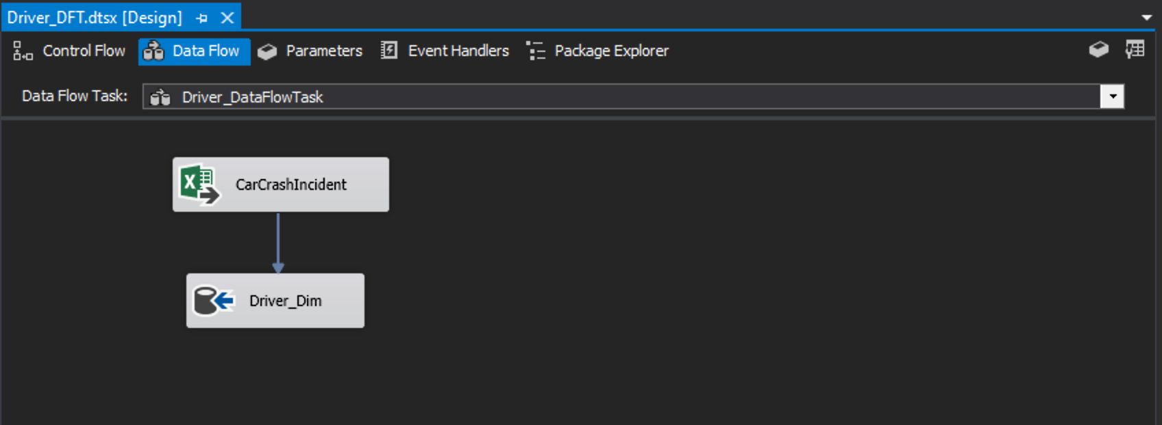

**ETL Data Flow to load data in the VEHICLE DIMENSION**

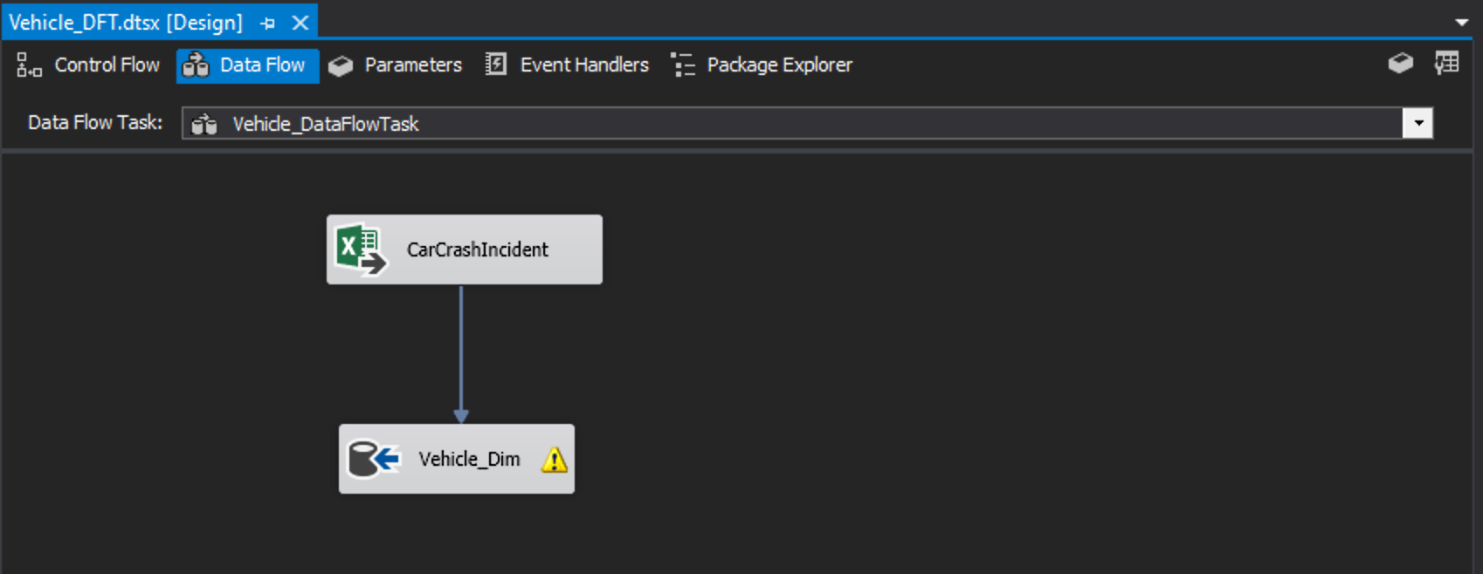

**ETL Data Flow to load data in the CRASH DATE DIMENSION**

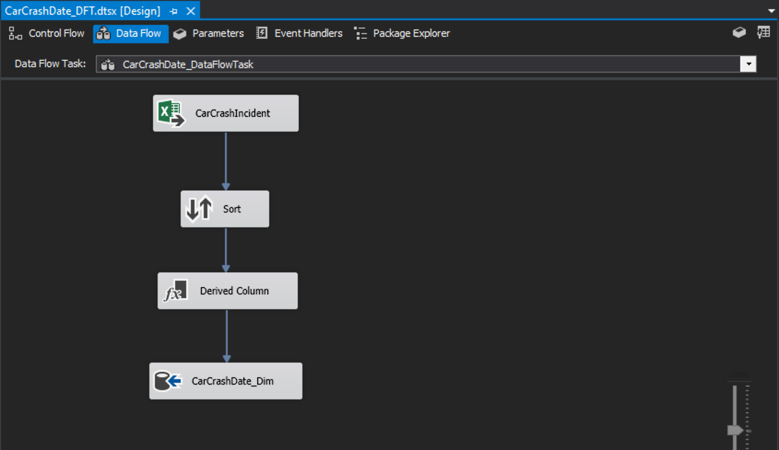

**ETL Data Flow to load data in the CRASH CONDITIONS DIMENSION**

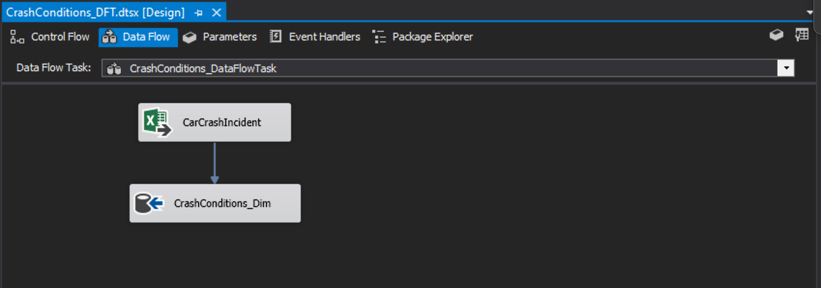

**ETL Data Flow to load data in the CASE DETAILS DIMENSIONS**

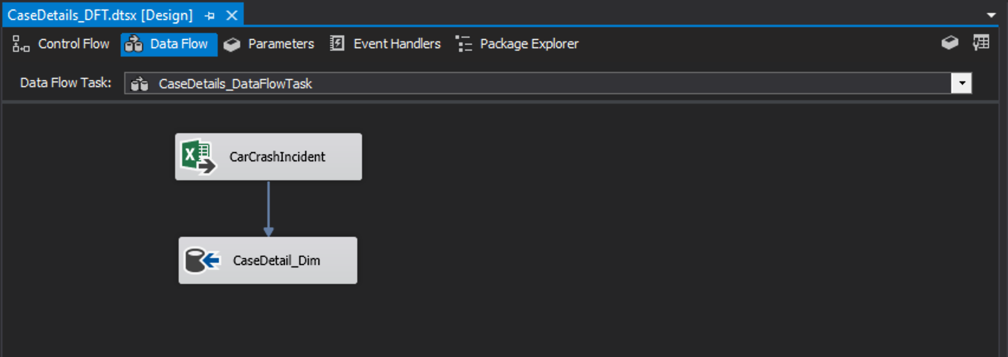

**ETL Data Flow to load data in the FACT TABLE**

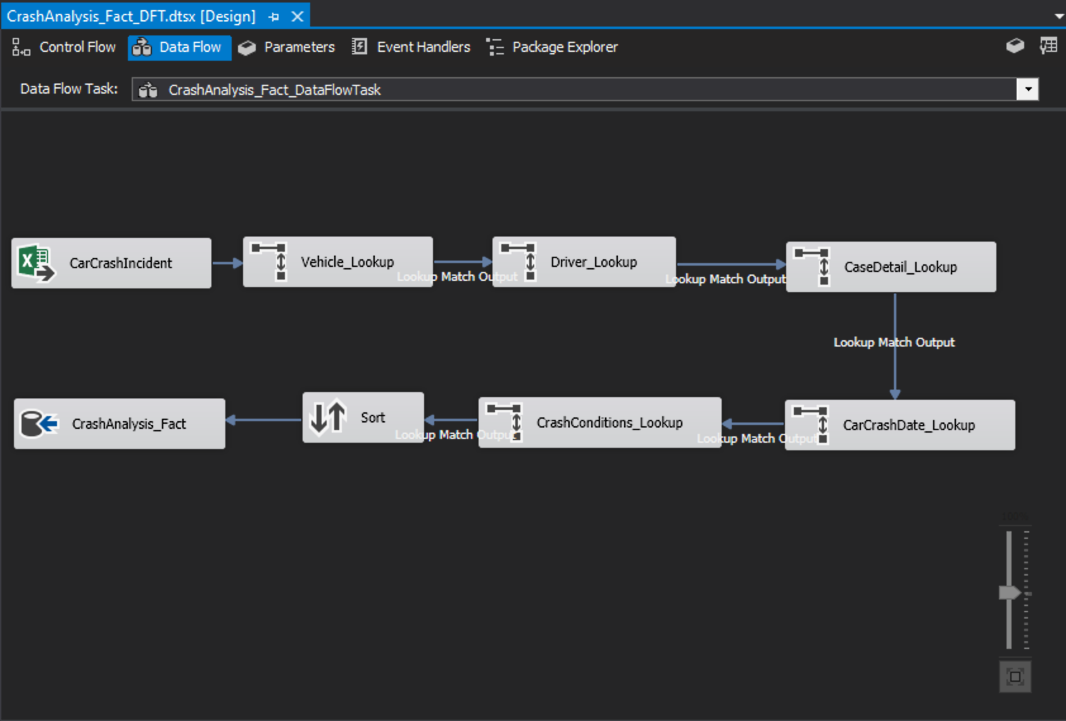

# 4. VISUALIZATIONS AND REPORTS

SSRS is server-based report generation tool by Microsoft. It was first launched in 2000, with the latest version released in 2016. It provides a set of integrated tools used primary for report generation, both mobile, paginated and traditional reports. SSRS can be directly integrated with Visual Studio. SSRS has a provision called “Report Building Tool”, which can be used by people having no special expertise with database.

Some of the different tools available in SSRS are:

* Report Builder
* Report Server
* Report Database
* Report Manager
* Reporting Services Configuration Manager

At its core, SSRS is driven by SQL Queries.

MS SQL Server also works harmoniously with R Studio. By using the RODBC/ODBC package available in R-Studio, developers can create a connection between the two softwares, store that connection in an instance and seamlessly access the database through SQL Queries like one would in an SQL environment. The versatility of R as a language when it comes to visual representation in the form of graphs, due to the availability of graph packages like ggplot2, combined with SQL queries, generate extremely insightful as well as visually appealing reports for analysis for any business requirement.

## 4.1. Visualizations

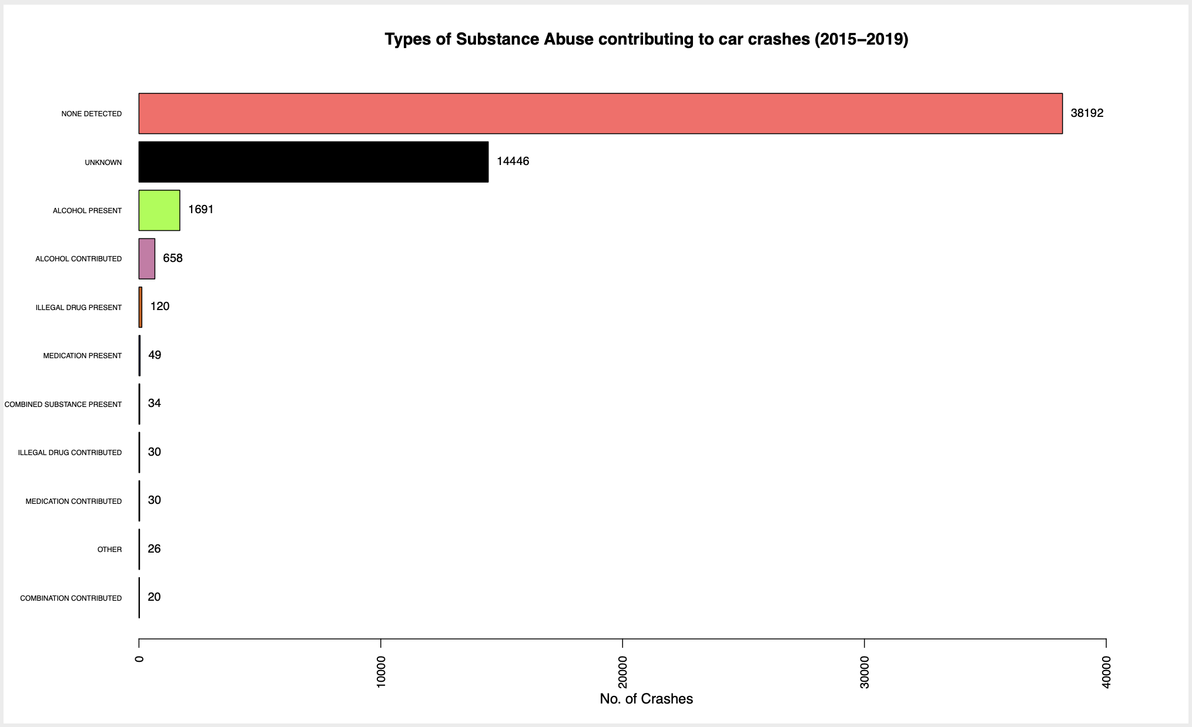

The above report is showing the types of substance abuse contributing to car crashes from the year 2015 to 2019.

As one can clearly see that in majority of the cases no substance was detected. Although it might seem to be a positive sign, it also indicates that there are other factors contributing to car crashes.

A significant number of cases have no clear evidence of substance presence/absence and therefore, have been categorized under “Unknown”. Unfortunately, alcohol once again is the leading contributor amongst substances. The “Alcohol Present” Bar shows that although alcohol was present in the victim’s blood, it may or may not be the contributing factor. But the next bar “Alcohol Contributed” shows that in 658 cases, presence of alcohol was the cause of accident.

Further going down, there are cases of illegal drugs, medicated drugs and combined substance. This shows that authorities of Maryland need to regulate these drugs and have a more severe check on driving under influence.

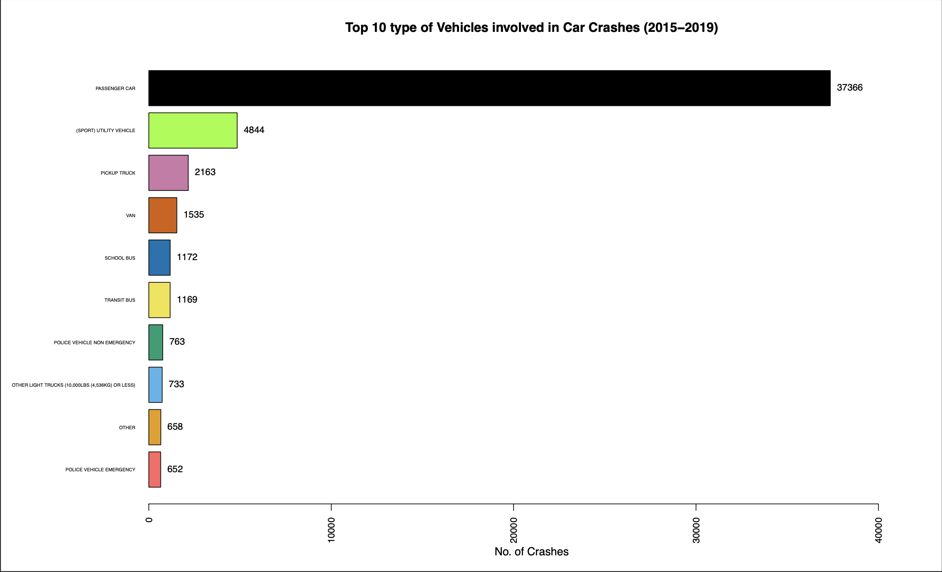

Out of the 31 types of vehicle present, we chose to explore the top 10 types of vehicles involved in car crashes from 2015 to 2019.

The number of Passenger Cars involved in car accidents are significantly higher than other class of vehicle amounting to 37366 which really is a point of concern. Next comes SUVs at 4844. Further down the list, the type of vehicles involved are usually heavy vehicles such as pickup trucks, vans, school buses, transit bus.

Passenger cars have quick acceleration and difficult to control at high speeds especially while driving on highways. Moreover, heavy vehicles such as trucks and buses tend to travel at comparatively lower speeds and have good resistance as well. This might explain the vast difference in number between the two vehicle classes.

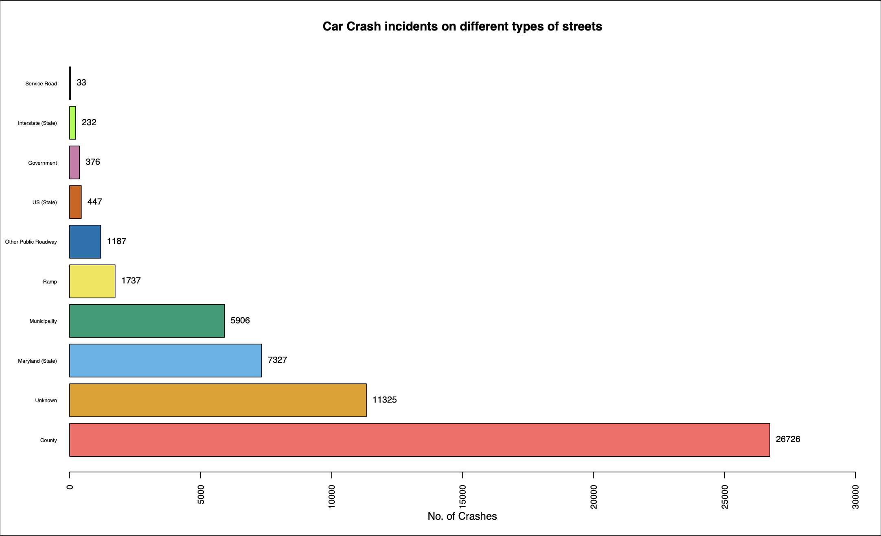

The above bar plot shows the count of accidents happened on the different types of roads.

Service Roads have the least number of accidents happened probably due to their narrow nature and low traffic. The number of car crashes that took place on Ramps and Public Roadways were moderate and higher as compared to Service Roads. One possible reason for these roadways showing a lesser accident count might be lesser traffic as compared roadways such as highways, interstate roads etc. Accidents caused on Municipality Road and State Roadways account for the third highest number of incidents.

As depicted by the graph above, there are significant number of cases where the roadway type is unknown and therefore, the data collection method needs to be improved so that we can gain more insight into the possible reasons behind these accidents.

Lastly, based on the above analysis we can clearly observe that County roads are the roadways where the greatest number of Accidents happened. Reason for such high counts of accident is because of open roads, no traffic signals and cars generally travelling at high speeds.

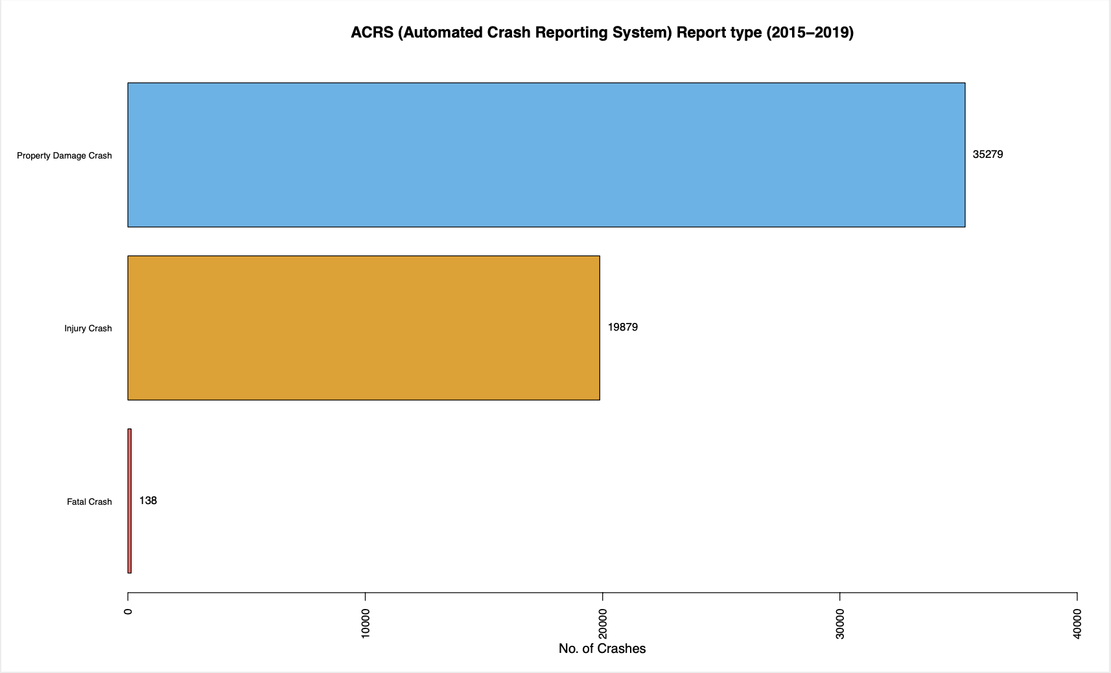

We have created this visualization report to identify the severity and damage level caused because of the car crash incidents.

As the plot shows, Property Damage Crash bar contributes to the highest number of damage events which only includes the damages done to the property. Property in itself is a vague term and in this context can mean anything from the actual cars involved, any indirect impact on other vehicles on the streets as well as damage to any surrounding physical property such as streetlamps, buildings etc.

Next is the **Injury crash** bar which is the second highest when it comes to the level of damage caused by the accident in which people (driver and / or any other person affected by the accident) got injured but did not suffer any major health / life-related problems.

And at the bottom is the Fatal Crash count showing the number accidents which had caused fatal injuries to the people which has led to serious damage or death.

## 4.2. Reports

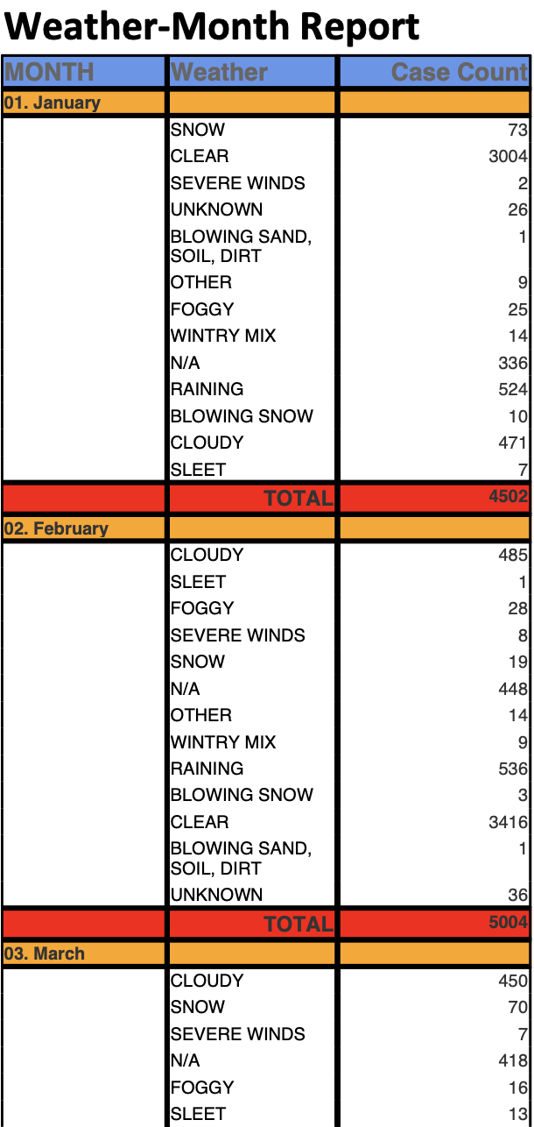 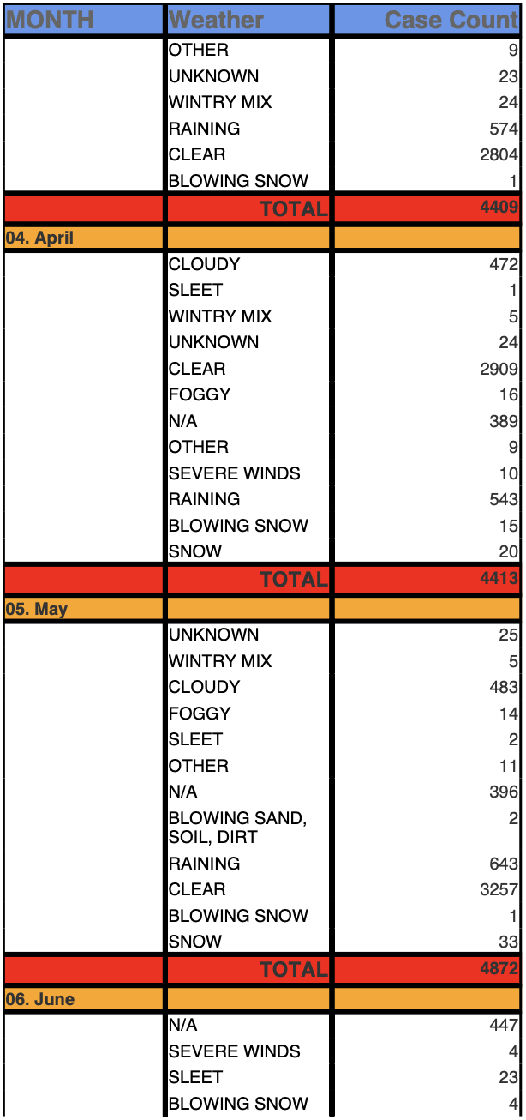

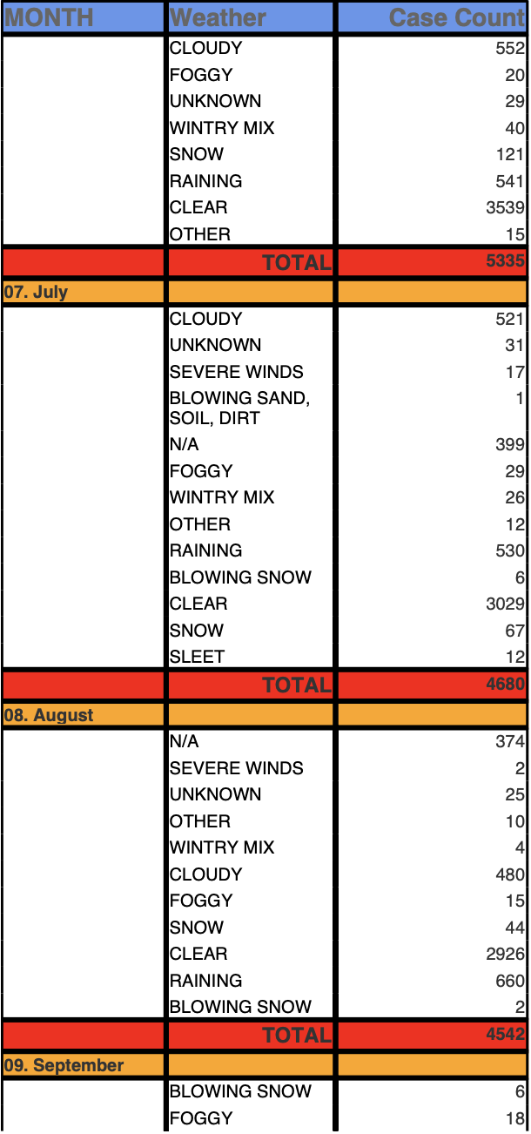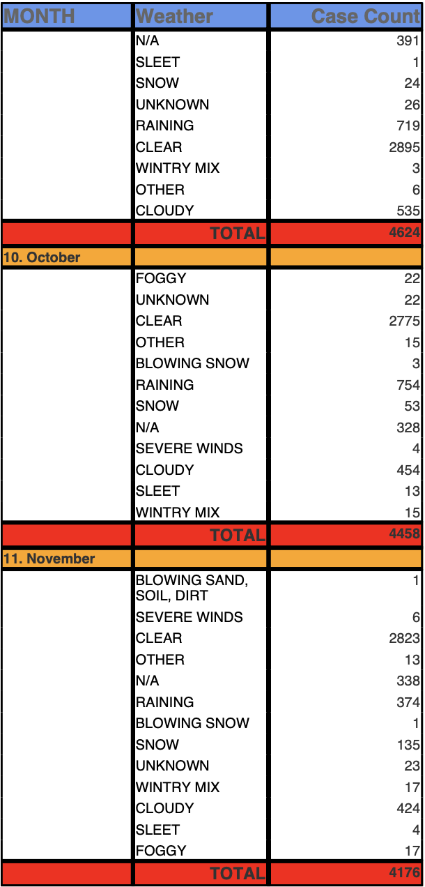

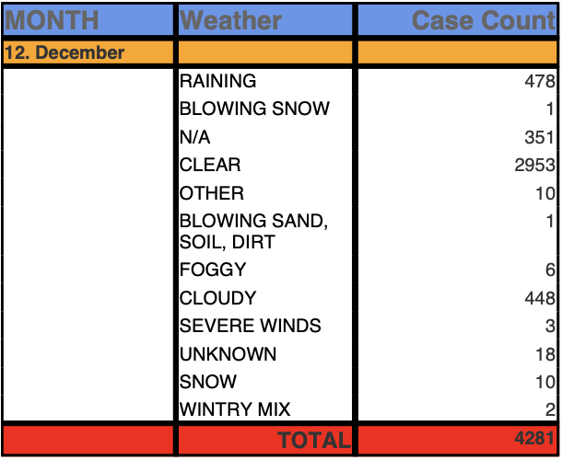

The above report generated through SSRS shows the month-wise weather conditions and the corresponding number of crashes that occurred during that weather.

As it can observed from the above report that almost 60% of the crashes were caused during clear weather which indicates that there might be other factors influencing the car accident. When it comes to other factors, Cloudy and Rainy weather have the second highest number of crashes. Slippery roads have always been a major cause of car accidents as the tires tend to lose traction and the driver loses control of the car, especially if travelling at high speeds.

Some other weather-related factors contributing to car crashes include blowing snow, fog and wintry mix which basically point to lack of visibility, which again can be an extremely dangerous weather to drive in.

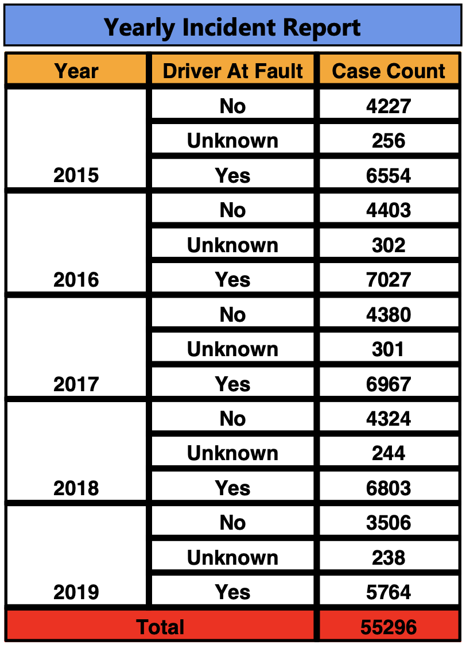

The above report gives us the detailed insight whether the car crashes happened because of Driver’s Fault or not.

As the report states from the year 2015 - 2019 around 60% of the accidents were caused due to Driver’s Fault (which could mean the contribution of alcohol, over speeding, distracted while driving etc. might be one of the reasons).

Approximately 3% of the data collected didn’t have enough evidence whether the driver was at fault or not.

For the rest 37% of the accidents the driver was not at fault. (which could mean other factors such as weather, due to some other vehicle on the road, a pothole on the road etc. might have caused the accident.)

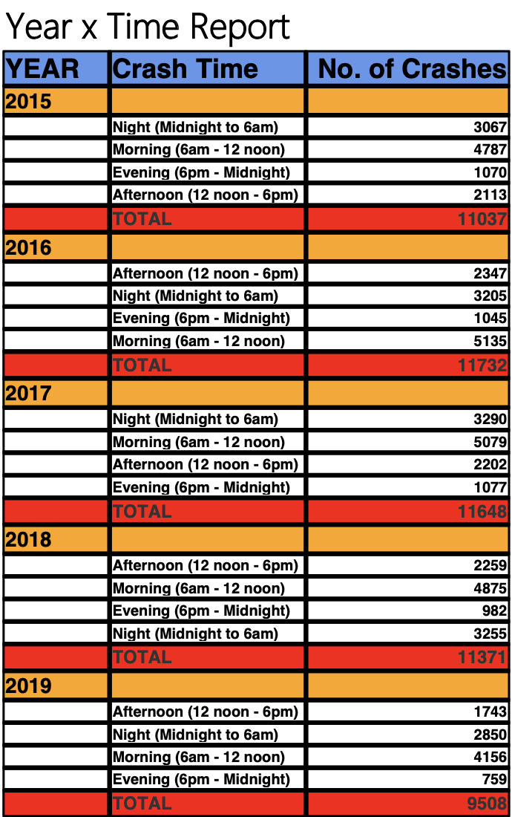

Our next subject of analysis was to find the time periods of the day during which the greatest number of accidents occurred from 2015 to 2019.

As per the report above, we can clearly observe that each year (from 2015-2019) the car crash count was more during the Morning (6 am - 12 noon) & Night (Midnight to 6am) time period, contributing more than 70% of the total car crash incidents. The possible reasons for such high a count as compared to the other time periods of afternoon and evening, might be the issue of low visibility during night time; tiredness of the driver during night time after a long day of work hence, leading to distractions or maybe falling asleep behind the wheel; rash driving during morning time (as it is peak rush hour time).

**PERCENTAGE CHANGE (BY MONTH)**

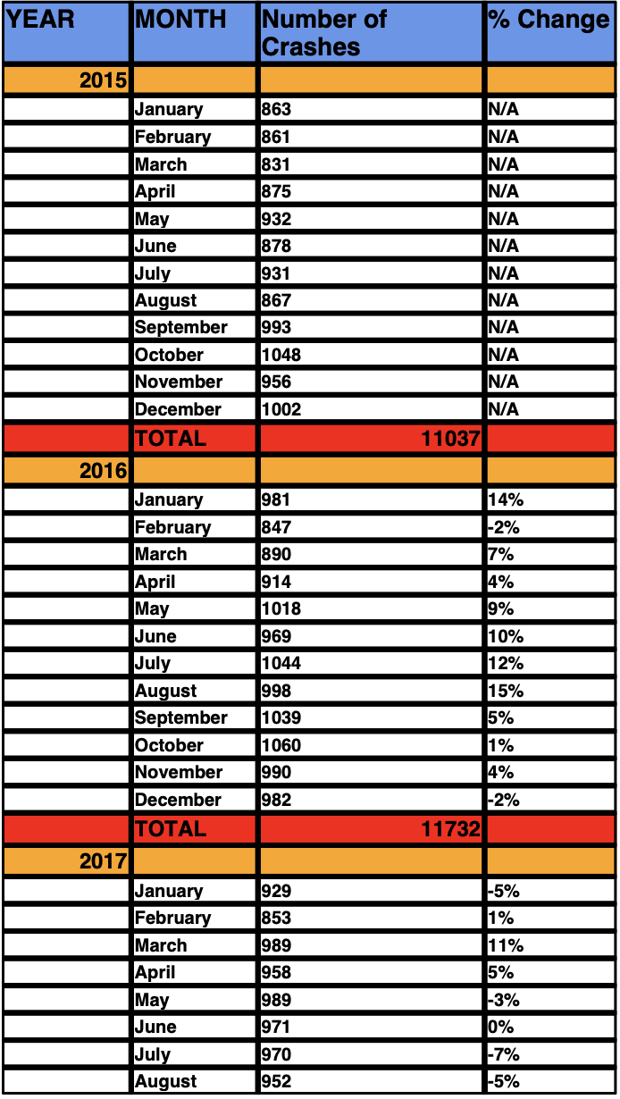 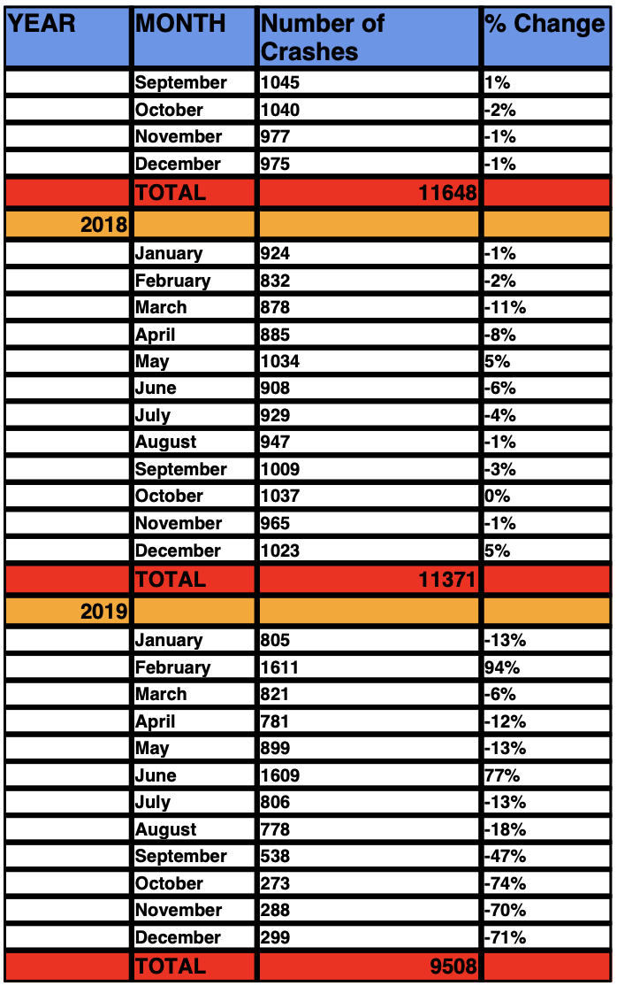

Generally, the percentage change between years have been sporadic with no definite pattern. In 2016, we saw in increase in accidents across the boards except the months of December and February which saw a decrease of 2% each. Similarly, for the year of 2017 and 2018, some months saw an increase in car crashes while some saw a decrease. In both the cases the change was minor.

Some major changes in numbers can be observed from 2018 to 2019.

* February 2018-19 saw almost double the number of crashes (94% increase)
* June 2018-19 also saw a significant increase (77%)
* September, October, November and December 2018-19 saw a major decrease in crash cases
* From 2018 to 2019, the number of reported car crashes decreased by almost 2000 cases.

**See Appendix A for codes for all the reports**

# 5. XML and Schema

XML or eXtensible Markup Language is defined set of rules that encode documents into a format that can be easily comprehended by Humans and machine alike. It is used to describe data and uses tags to define the data’s metadata. I.e., just like HTML, another markup language, it uses tags to describe the what kind of data it is. These tags make up the elements of the XML. All elements are contained in a hierarchical structure with a root element at the top. An XML document is considered well structured, if it complies to the World Wide Web Consortium (W3C) specifications. (W3schools.com, 2019)

An XML needs a Schema when it needs to define a legal building blocks of an XML document. Schema can be defined for the XML Document in two ways:

1. **DTD**

A DTD is a Document Type Definition, it defines the legal elements and the attributes of the document from a SGML (Standard Generalized Markup Language). (W3schools.com, 2019).

<!ELEMENT note (to,from,heading,body)>  
<!ELEMENT to (#PCDATA)>  
<!ELEMENT from (#PCDATA)>  
<!ELEMENT heading (#PCDATA)>  
<!ELEMENT body (#PCDATA)>

1. **XML Schema**

It is also referred to as XML Schema Definition or XSD. It uses the same technique as the XML, i.e., a markup style document to describe the data. (W3schools.com, 2019)

<?xml version="1.0"?>  
<xsd:schema xmlns:xsd="http://www.w3.org/2001/XMLSchema">  
<xsd:element name="note">  
  <xsd:complexType>  
    <xsd:sequence>  
      <xsd:element name="to" type="xs:string"/>  
      <xsd:element name="from" type="xs:string"/>  
      <xsd:element name="heading" type="xs:string"/>  
      <xsd:element name="body" type="xs:string"/>  
    </xsd:sequence>  
  </xsd:complexType>  
</xsd:element>  
</xsd:schema>

**Advantages of XML**

* Simplicity.
* Open standard and platform/vendor Independent.
* Extensibility.
* Reusability.
* Separation of content and presentation.
* Support for integration of data from multiple sources.
* Ability to describe data from a wide variety of applications.
* More advanced search engines.

For this project we created an XML Schema, instead of a DTD, which adhered to the Star Schema that was implemented in our data warehouse. This XML Schema includes a root element called CrashAnalysisDetails. All other dimensions such as CrashAnalysis_Fact, which defines the Fact Table of the schema, Vehicle_Dim, describing the Vehicle description, Driver_Dim, describing the Driver's details, the CrashCondition_Dim, explores the conditions during the crash, CaseDetails_Dim, which defines the ACRS case details and CrashTime_Dim, which records the time of the crash are also created and included within the root element. The Elements are kept according to a sequence in the xsd:sequence tag and have unbounded max occurrence. The xsd also defines the Primary key for each dimension and also for the fact table. Unlike other dimension, we have declared a composite key for the fact table. The other keys are referenced to the corresponding fact table's primary key. We have carefully created these dimensions in accordance with our star schema to maintain integrity and structure of data. While creating the XML document, special attention was given in filling in data between each tags and adhering to the primary and foreign key referencing constraints.

**XML Document**

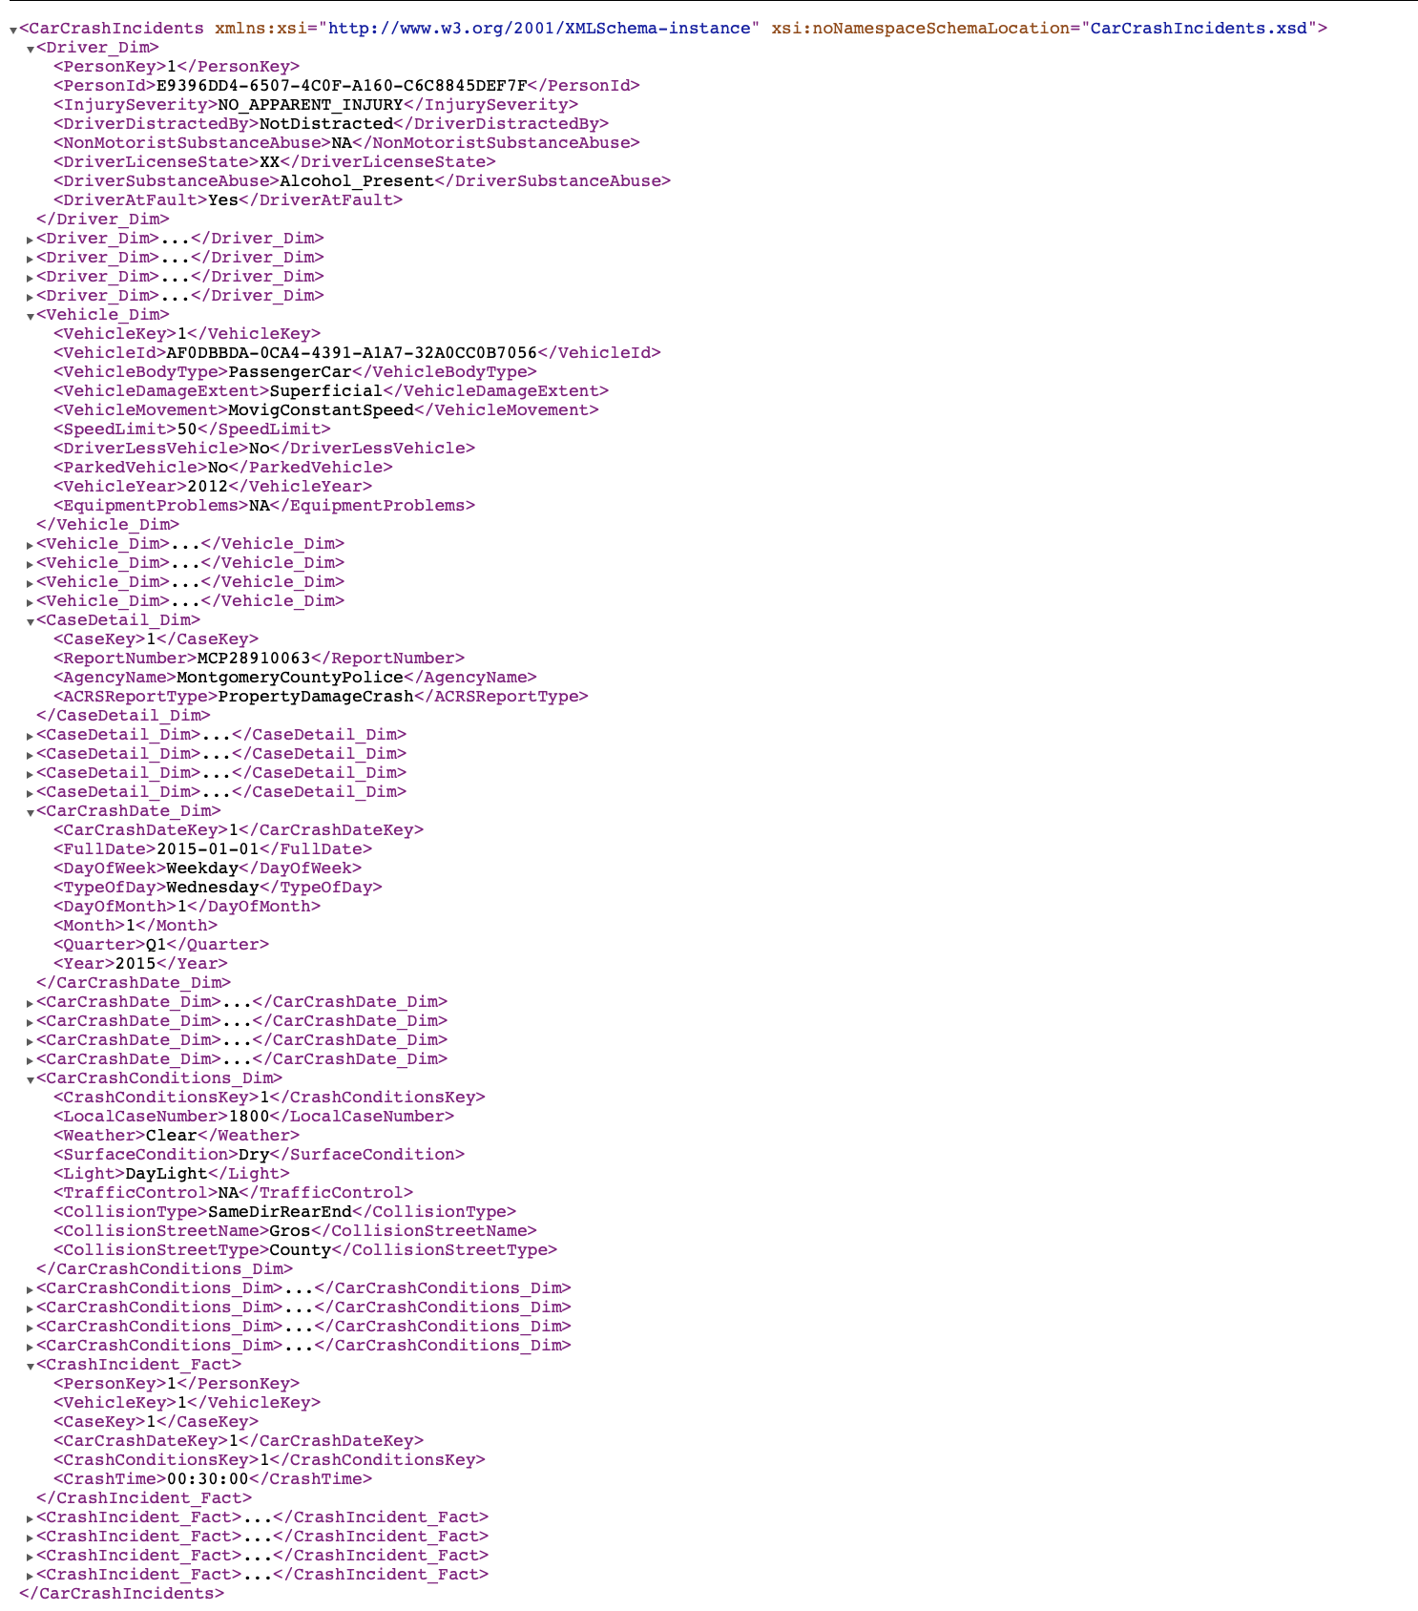

**XML Validation**

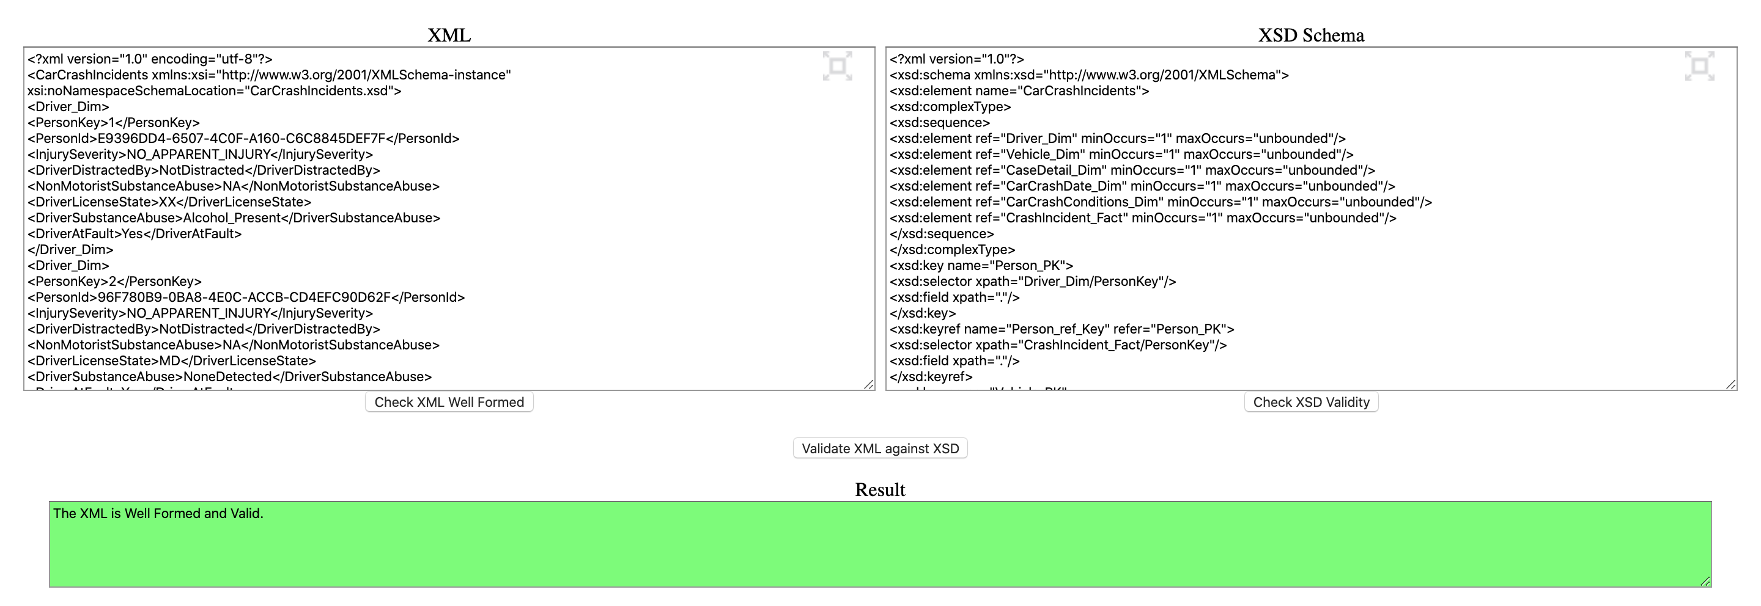

# 6. Graph Databases

Neo4j is one of the most widely used open source graph database. A graph database is used to model data in the form of graphs. These models are mainly used when data volume is too large and the relationship among different entities is more important than the data itself.

In Neo4j we use circles and intersection lines to represent entities and their relationships. Different types of available graphs in Neo4 are:

* + Undirected graphs
  + Directed graphs
  + Graphs with weight
  + Graphs with labels
  + Property graphs

Major advantages of Neo4j are : **Performance, Responsiveness, Flexibility** and **Scalability.**

For this part of the project, we created a Graph database representation of our SQL Datawarehouse using Neo4J. For this representation we just used the 1st 100 records from all tables and stored them in different csv files in the import folder of our Neo4J Database. While creating the graphs for the individual dimensions and fact table, special attention was given to the column names and datatypes. After successful creation of the graphs, constraints were enforced on the tables to maintain integrity of data and relationships were established from the fact table to other dimensions to create a star schema like structure.

Further, we compared Neo4J to MS SQL Server by running some sample queries and comparing queries as well as outputs. In our project we have shown a WHERE condition query, a DISTINCT query, a COUNT query and a JOIN query.

**DRIVER DIMENSION USING NEO4J**

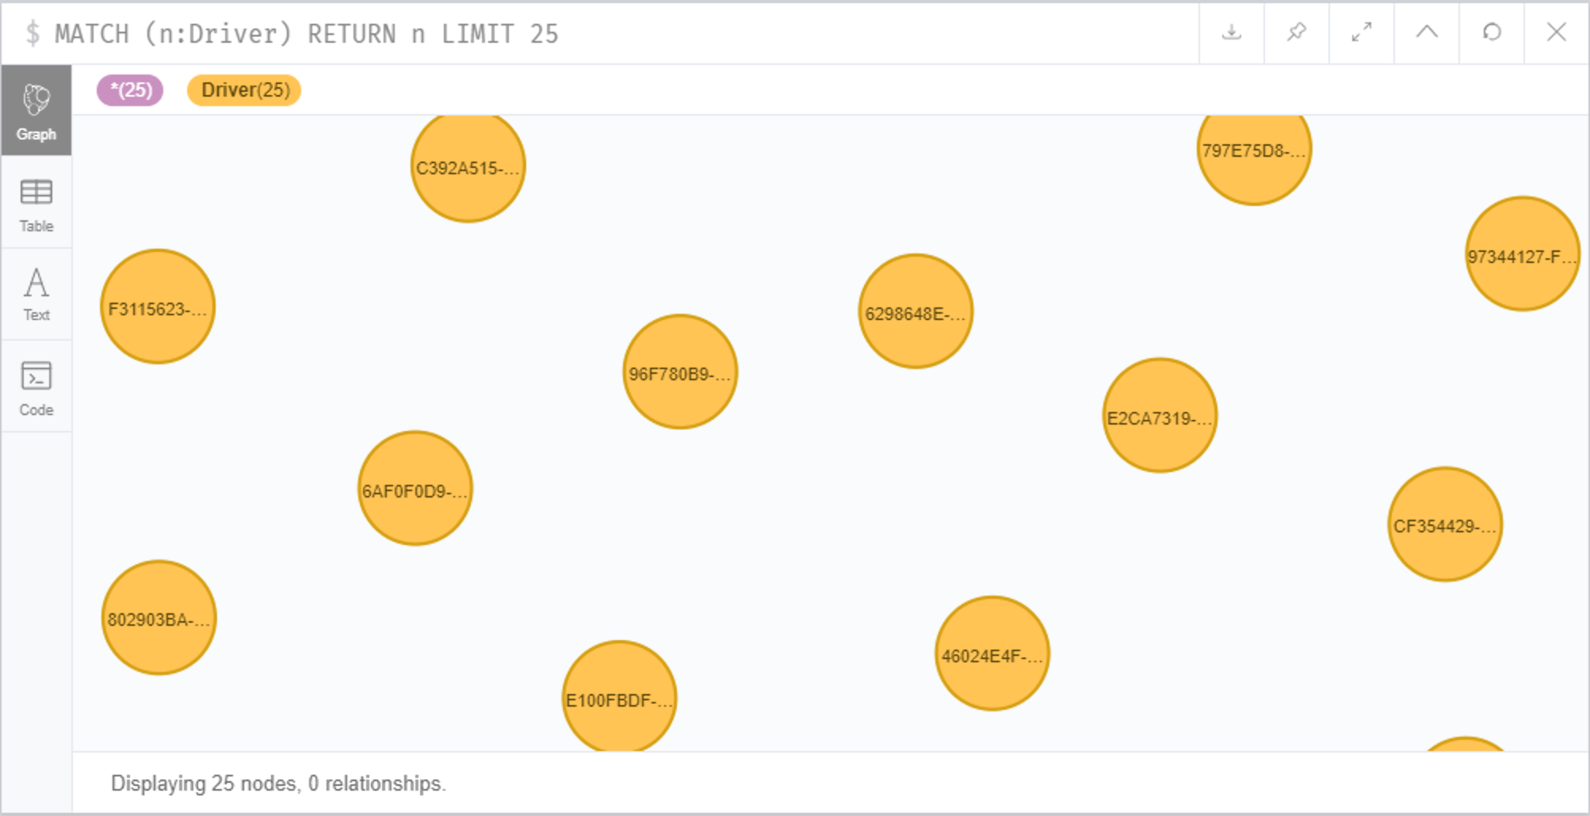

**VEHICLE DIMENSION USING NEO4J**

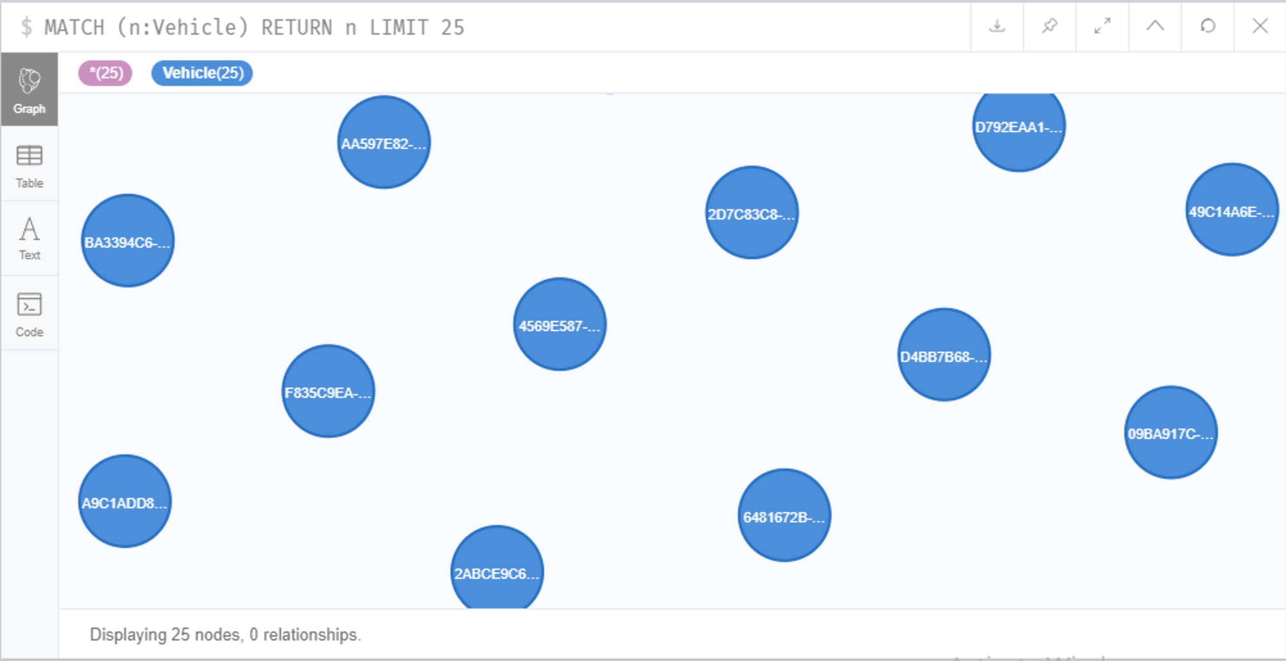

**CRASH DATE DIMENSION USING NEO4J**

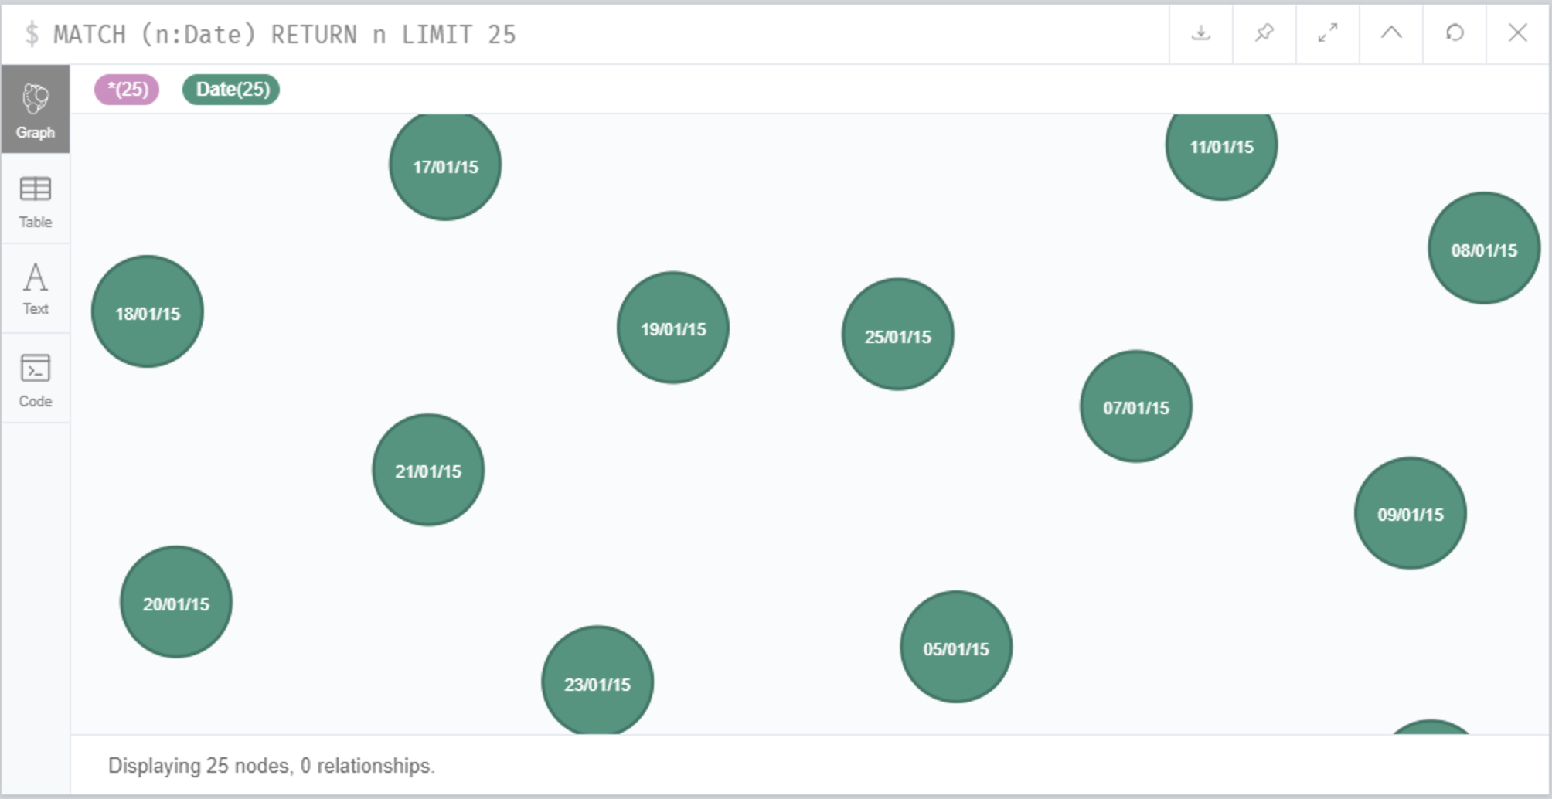

**CRASH CONDITIONS DIMENSION USING NEO4J**

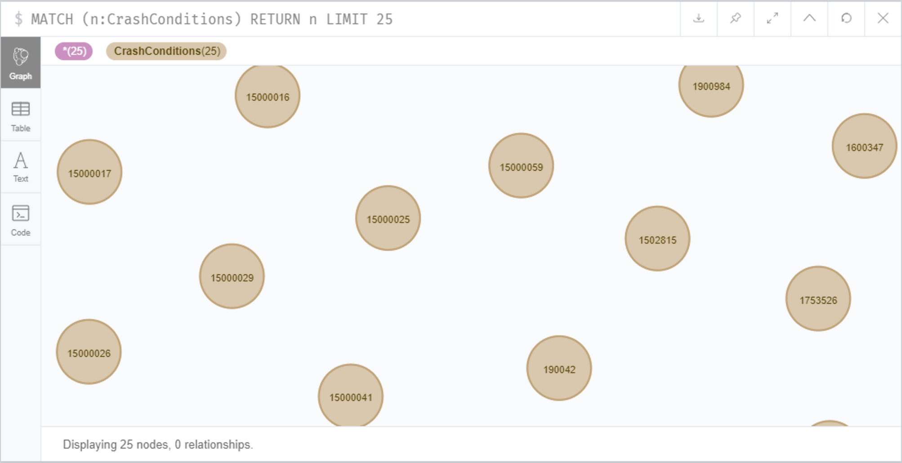

**CASE DETAILS DIMENSION USING NEO4J**

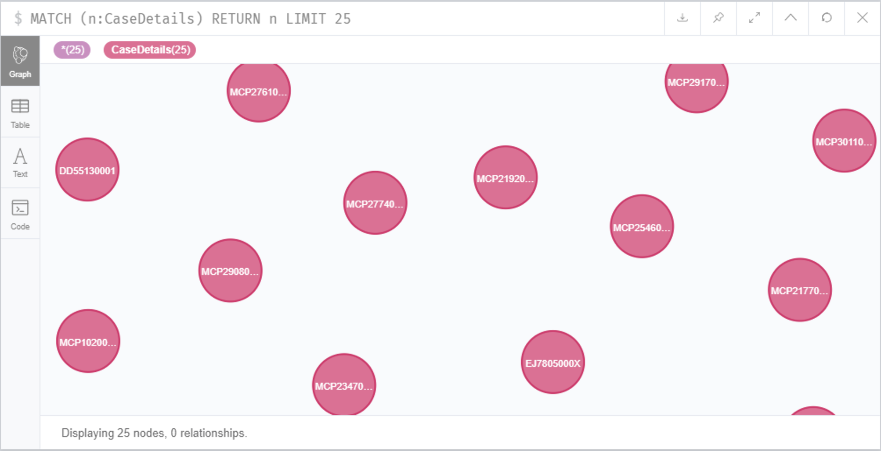

**FACT TABLE USING NEO4J**

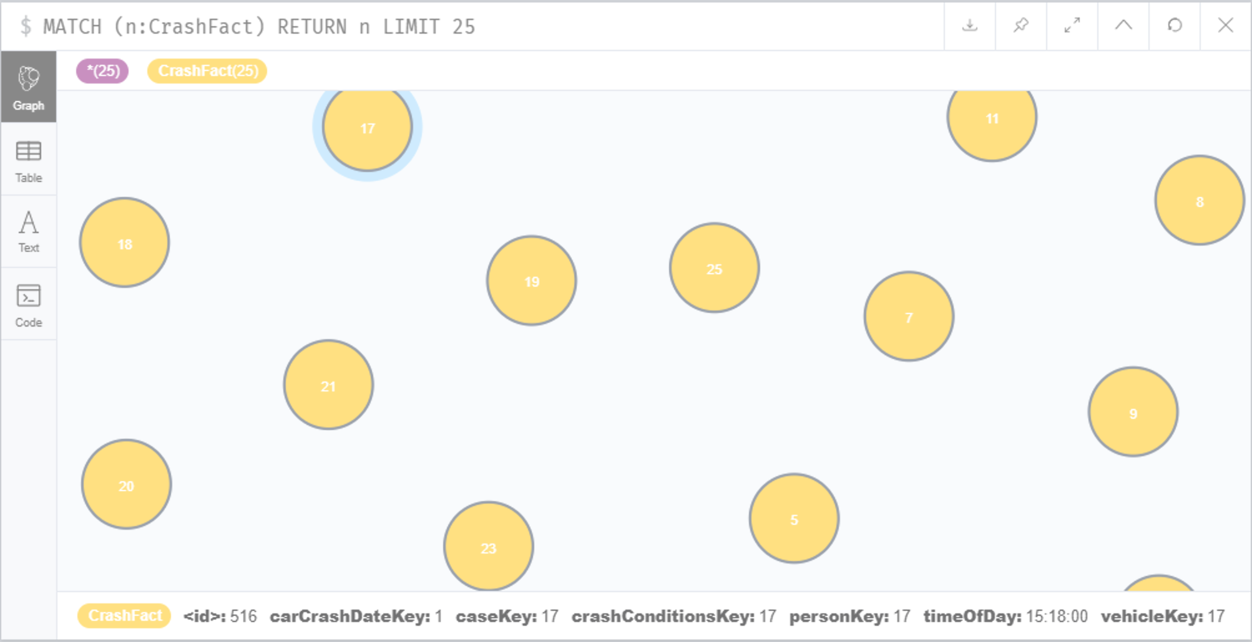

**CONNECTED GRAPH AFTER IMPLEMENTING RELATIONSHIPS AND CONSTRAINTS**

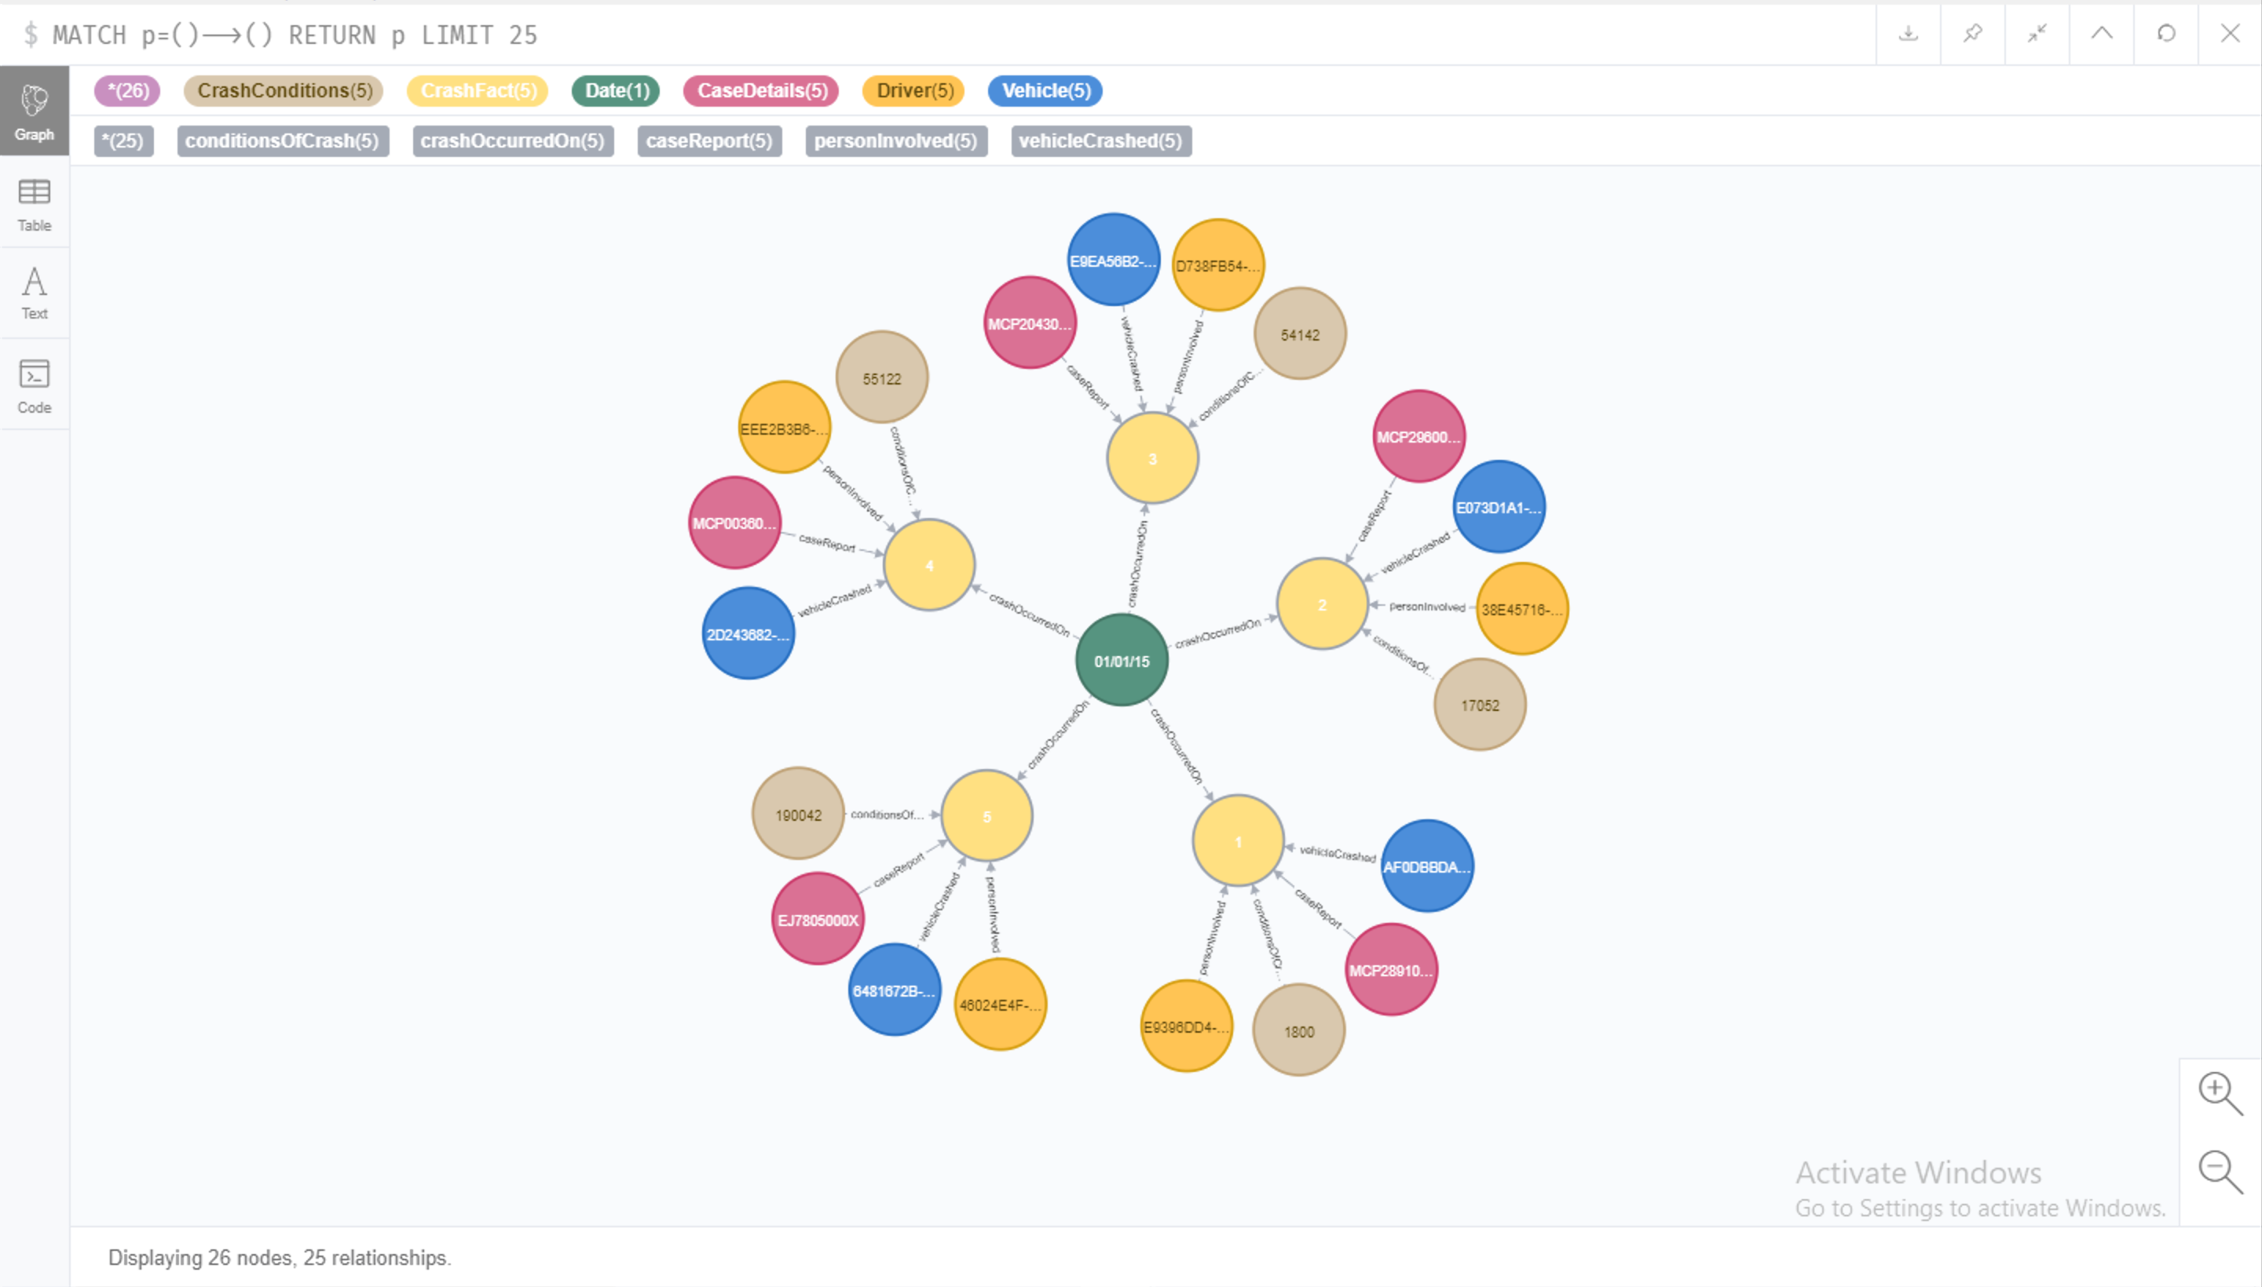

## 6.1. COMPARISON To Relational Databases

Graph databases didn’t come into the limelight until recent years when people started to realize their advantages over relational databases. With explosion of data, existing databases required to handle frequent schema changes, managing high volume of data, real-time query response and intelligent activation requirements. With the inception of Graph databases, these problems were solved and processes were streamlined.

**ADVANTAGES OF GRAPH DATABASES OVER RELATIONAL DATABASES**

* Object-oriented thinking: In Neo4J, the developer declares object instances for each table which makes join queries much easier to implement.
* Graph databases have superior performance when it comes to querying databases as compared to SQL databases as at the core, graph traversing algorithms such as Dijkstra, BFS, DFS etc. are used to reach the required node.
* Graph databases help solve both practical and impractical problems for relational queries.
* They can perform real-time updates on big databases while supporting queries at the same time
* These databases offer a flexible online schema environment where you can constantly add, remove and modify nodes, vertex to expand/shrink your data model.
* For analysis purposes, one can use graph databases to find direct as well as indirect links by traversing edges and vertices to find connections.

**“WHERE” CONDITION QUERY**

**NEO4J**

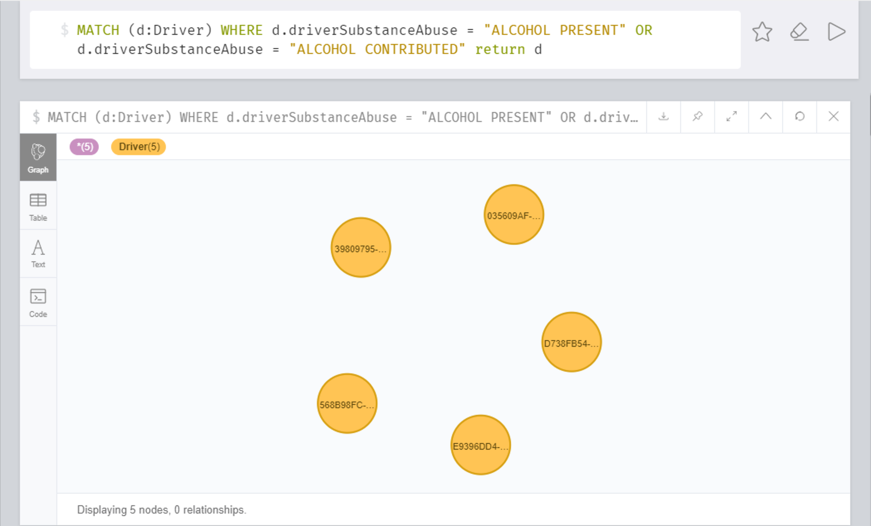

**SQL**

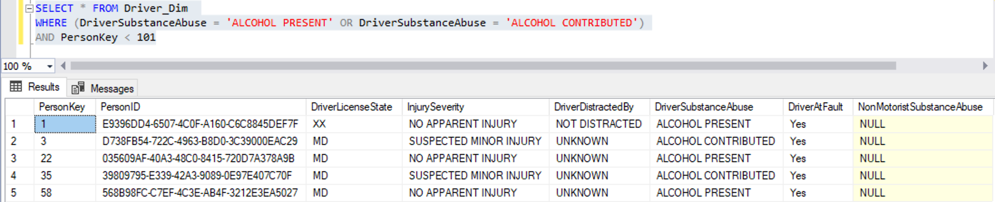

**“COUNT” QUERY**

**NEO4J**

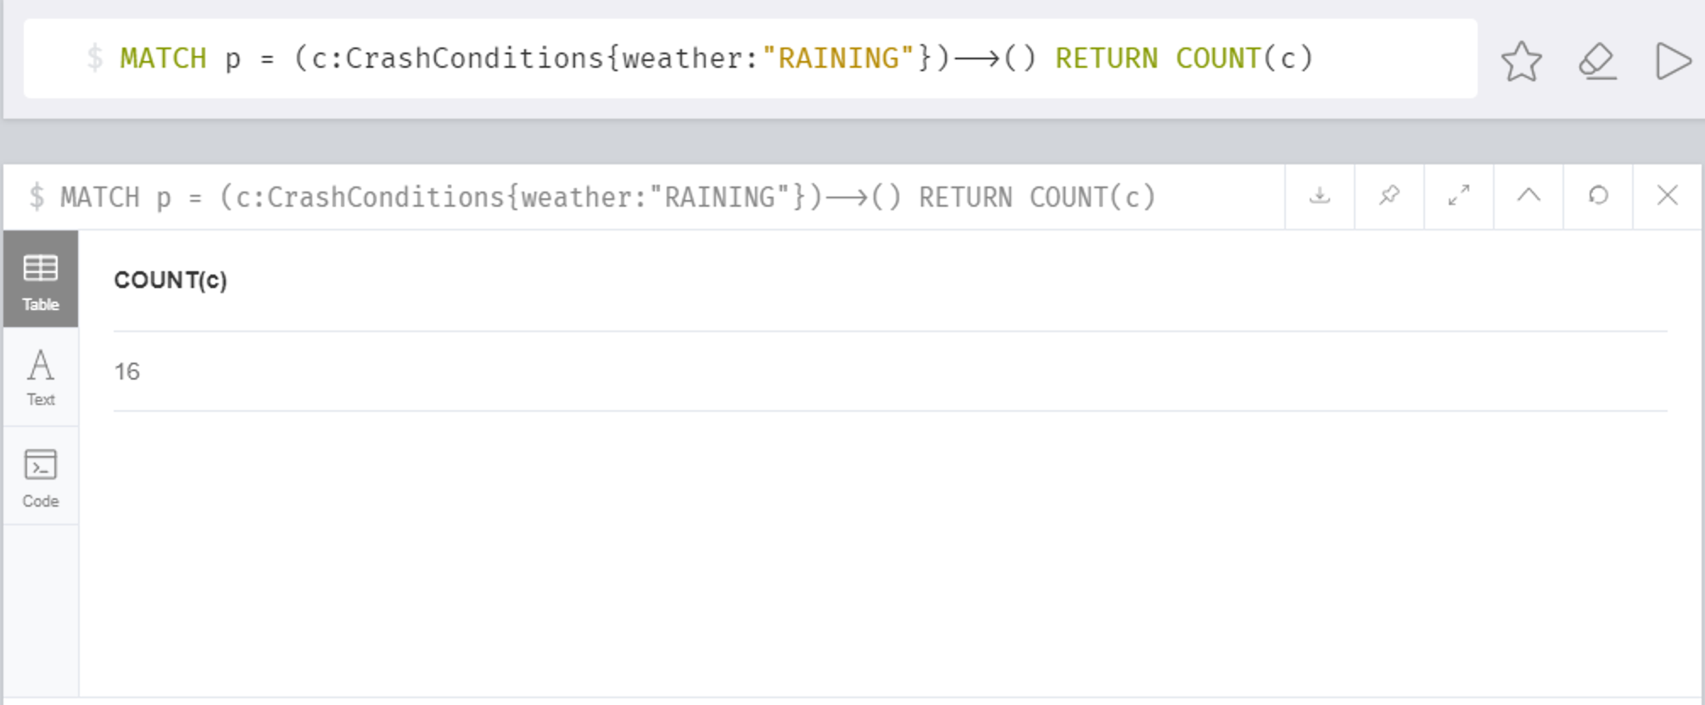

**SQL**

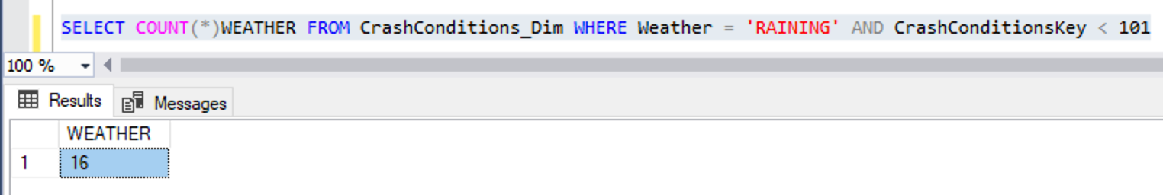

**“DISTINCT” QUERY**

**NEO4J**

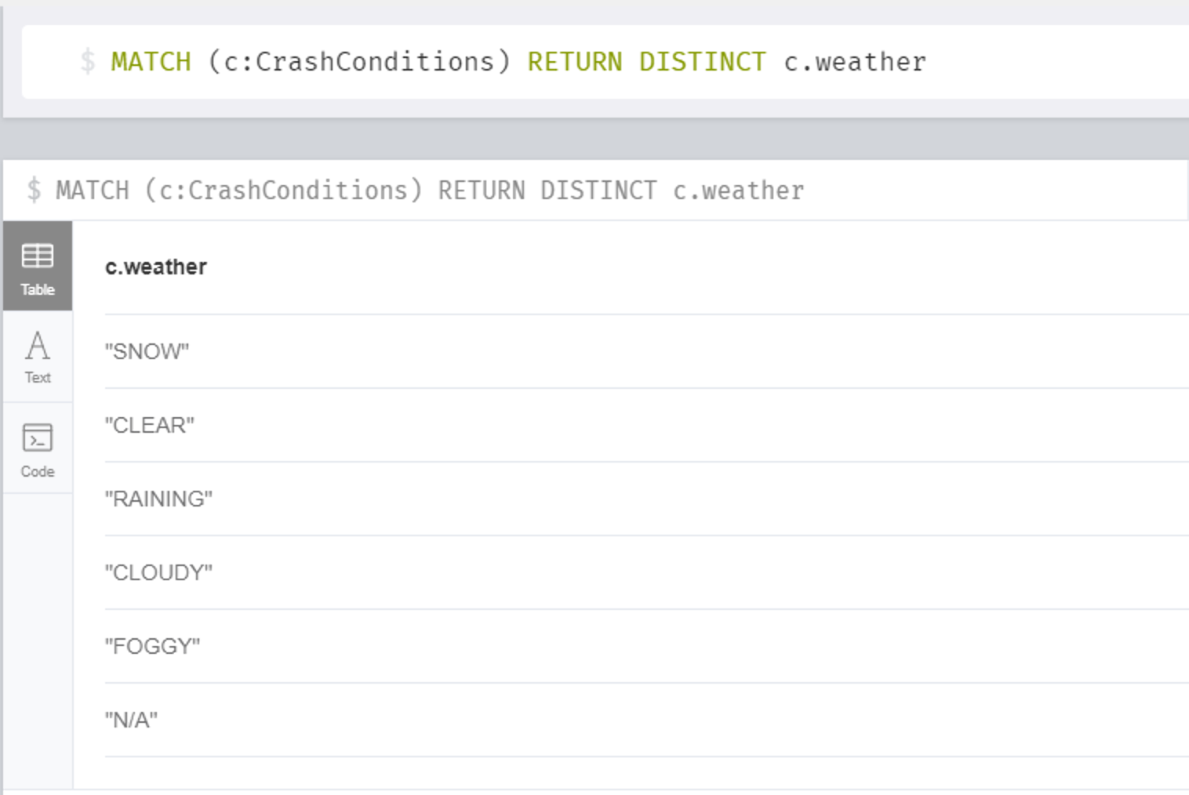

**SQL**

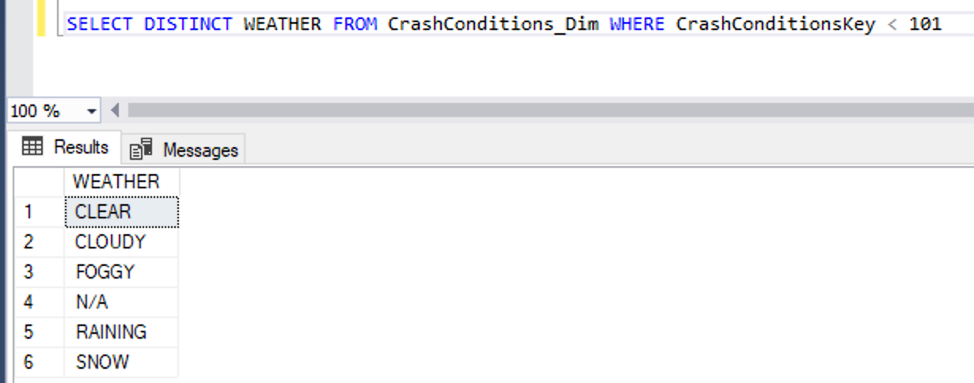

**“JOIN” QUERY**

**NEO4J**

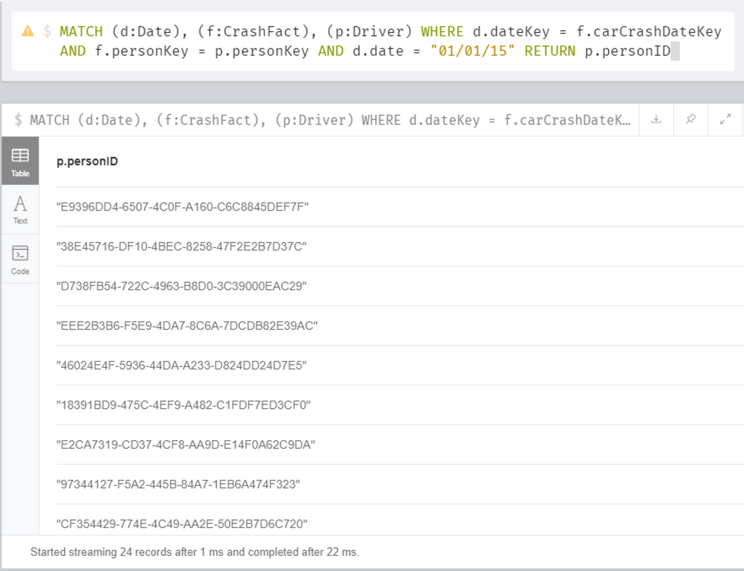

**SQL**

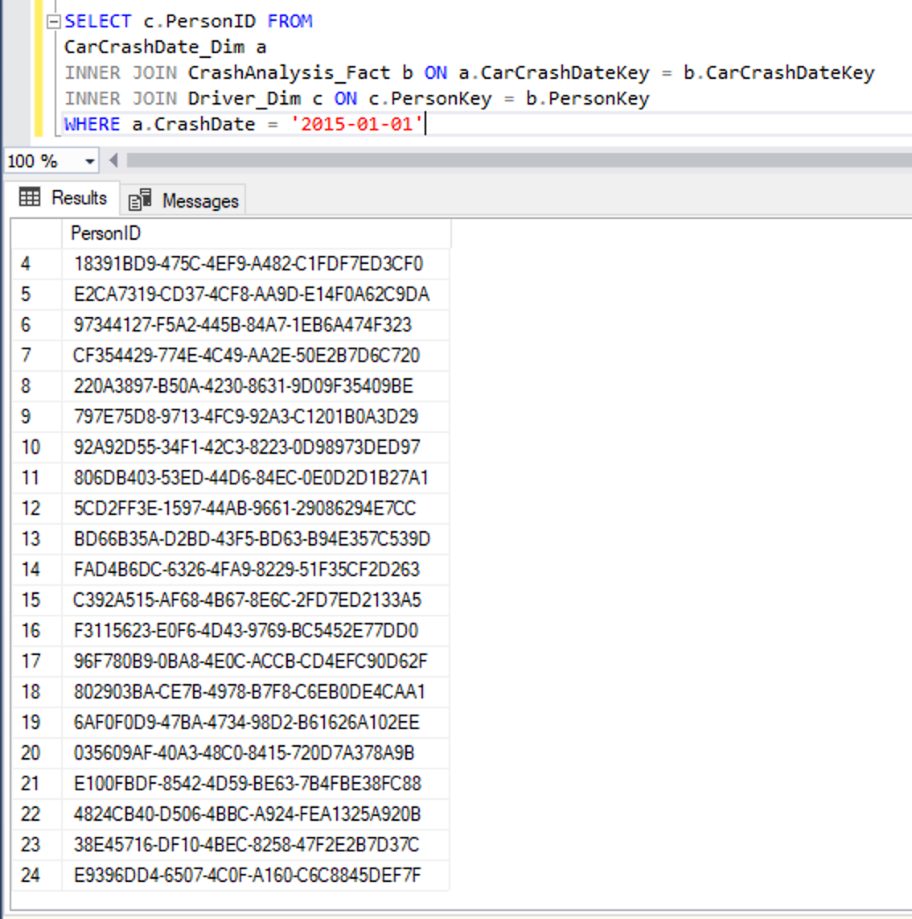

# 7. Bibliography

[1] Data.world. (2019). Crash Reporting - Drivers Data - dataset by montgomery-county-of-maryland. [online]

Available at: <https://data.world/montgomery-county-of-maryland/0ca5b758-c60a-40c7-bfb5-fda26ceee4c8>

(Accessed 25 Oct. 2019)

[2] Datawarehouse: What is Data Warehousing? Types, Definition?

Available at: <https://www.guru99.com/data-warehousing.html#1>

(Accessed 9 November 2019)

[3] Understanding Star Schema

Available at: <http://gkmc.utah.edu/ebis_class/2003s/Oracle/DMB26/A73318/schemas.htm>

(Accessed 9 November 2019)

[4] SSIS: Why SSIS and difference between SSIS & ETL

Available at: <https://www.quora.com/What-is-the-difference-between-SSIS-and-ETL>

(Accessed 9 November 2019)

[5] SSIS: SQL Server Integration Services Installation & how to use SSIS for table creation?

Available at:

1. <https://www.youtube.com/watch?v=0ikNnenDyNw>

2. <https://www.youtube.com/watch?v=FFRbbLz5bhY>

3.  <https://docs.microsoft.com/en-us/sql/integration-services/ssis-how-to-create-an-etl-package?view=sql-server-ver15>

(Accessed 11 November 2019)

[6] ETL Process to Populate Staging Table and Fact Table

Available at: <https://www.youtube.com/watch?v=XVms0SA-6Xs>

(Accessed 11 November 2019)

[7] SSRS: What is SSRS?

Available at:

1.<https://www.quora.com/What-is-SSRS>

2. <https://docs.microsoft.com/en-us/sql/reporting-services/create-deploy-and-manage-mobile-and-paginated-reports?view=sql-server-ver15>

3. <https://en.wikipedia.org/wiki/SQL_Server_Reporting_Services>

(Accessed 17 November)

[8] How to Create SSRS Report?

Available at:

1. Moodle: <https://elearning.dbs.ie/mod/url/view.php?id=728176>
2. <https://www.youtube.com/watch?v=r-TxvDbanY4>

(Accessed 21 November 2019)

[9] W3schools.com. (2019). *XML Tutorial*. [online]

Available at: <https://www.w3schools.com/xml/default.asp>

(Accessed 1 Dec. 2019).

[10] W3schools.com. (2019). DTD Tutorial. [online]

Available at: <https://www.w3schools.com/xml/xml_dtd_intro.asp>

(Accessed 1 Dec. 2019).

[11] W3schools.com. (2019). XML Schema Tutorial. [online]

Available at: <https://www.w3schools.com/xml/xml_dtd_intro.asp>

(Accessed 1 Dec. 2019).

[12] NEO 4j: Capabilities and use of Neo4j Graph database in real life?

Available at:

1. <https://rubygarage.org/blog/neo4j-database-guide-with-use-cases>
2. <https://en.wikipedia.org/wiki/Neo4j>

(Accessed 12 December 2019)

[13] Neo4j Tutorial: To understand about Neo4j and how write codes in Neo4j

Available at:

1. Moodle: <https://elearning.dbs.ie/mod/resource/view.php?id=824802>
2. <https://www.tutorialspoint.com/neo4j/neo4j_overview.htm>

(Accessed 12 December 2019)

[14] Neo4j: What are the major advantages of using a Graph Database?

Available at: <https://dzone.com/articles/what-are-the-pros-and-cons-of-using-a-graph-databa>

(Accessed 12 December 2019)

# Appendix A – VISUALIZATIONS Code

**ORD**

**E**

**  **

**R BY Customers.CustomerID;**

# Appendix B – Neo4J code

 

# Appendix C – xml code

 

# APPENDIX D – Datawarehouse CREATE Queries



**SSRS Report PDFs, R Plot PDFs, SSIS Project and Packages, Neo4J screenshots and an extra copy of all Queries & Scripts are attached along with the document in the Zip Folder.**